Royal Bus Service(Online Bus Ticket Reservation System)

**Group Members**

| *S.no* | *Student ID* | *Student Name* |
| --- | --- | --- |
| 1 | Student1311372 | Mehwish |
| 2 | Student1311862 | Iqra Waheed |
| 3 | Student1316319 | Ghazali Warsi |

**Project Advisor**

Miss. Nazish Sattar



**Aptech Computer Education**

Korangi Center

**ACKNOWLEDGEMENT**

First of all we would like to thank ALLAH the almighty who make us able to complete this project.

After that we would like to express profound gratitude to our internal project advisor, Center Senior Faculty, ***Miss. Nazish Sattar***, for her precious support, back-up, supervision and useful suggestions throughout this project. Her moral support and continuous help enabled us to complete our work successfully. We are also highly thankful to the ***Center Management*** for their valuable suggestions, healthy analysis and support throughout this project.

We are grateful to the faculty members of Aptech Korangi Center who were always there to help us despite of their personal workload.

We are as ever, especially indebted to our parents for their love and support throughout our life. We also wish to thank our classmates, friends and all the individuals or groups that were involved in this project by any mean.

- Mehwish Asif

- Iqra Malik

- Ghazali Warsi

# **E-Project** **Synopsis**

## Introduction

It’s an online service application where We can maintain the records of the buses along with the details of the customers. The customer can now book the tickets by visiting the booking counters at their place (near by) to the respective destination as required. The application is linked with the database, so that what ever details are entered like the details of the customers, buses, and bookings can be viewed by the other centers as well as it is an online application. The application has some feature which performs the tasks that they actually perform, and an application where the customer can register with the site and then book the tickets online instead of visiting the booking counter A database has maintained where the bus details along with the bus number, route, the places it covers through out the distance and also the timings are maintained here. Also the details of the customers that are entered at the time of booking the tickets are gathered in the database. So that they can track the details of the customer at any time using the search option based on the starting place, age, name,

destination place and Date and Time and even based on the bus they chosen.

There is a buttons like New, Update and Cancel are included. Based on the button chosen the respective action is performed. Also if the Employee record is entered (The Employee details maintained by the Admin ), it automatically generate a six digit code, and it will ask for the username and the password (the password can be changed by the Employee) through which he can login in to the a/c so as to perform the booking tasks.

The application to be maintained in different details like the buses and the bookings information. When they try to book a ticket it ask for the customer details like the name of the customers for whom the tickets are booked, Date and Time, Starting and Destination place and the age ( as the charges depends on the age). Also the Bus no. and the seat no. for which the ticket (s) booked are to be entered so that they can keep track of the bookings done.

Whenever a customer enquires for the availability they can check through the Enquiry form where the details like Destination Place, Starting Place, Date and Time are asked, by entering these details (all fields are not mandatory) the availability details is display. Also there is a search option through which the records of the customers and the buses can be known easily with the same above options.

## Objective

# The Objective of this program is to give a sample project to work on real life projects. These applications help you build a larger more robust application.

# The objective is not to teach you topic but to provide you with a real life scenario and help you create basic applications using the tools.

# You can revise these chapters before you start with the project.

# These programs should be done in the Lab sessions with assistance of the faculty if required.

# It is very essential that a student has a clear understanding of the subject.

# Kindly get back @ eprojects@aptechfze.ae in case of any doubts regarding the application or its objectives.

## Technology Used

In order to meet the requirement of our project we have used following underlying technologies.

* JavaScript
* jQuery
* Entity Framework
* SQL
* Bootstrap 5
* Font awesome
* Icons
* Database
* Asp.NetCore
* .Net



*Figure 1: Technology Used in Project*

## Application Features

* We have used Asp.NetCore so as to make our Application Dynamic. Although it is not as Dynamic as professional apllication are, but we have tried basic implementation of a Dynamic Apllication.
* Smooth hovering effects have been used.
* Two Types Of Admin Panel.
* Color combination is according to Logo.
* Online Tickets Reservation and search option where customer check the seat avaibility.
* Update,Delete,Edit method for admin only where admin can Edit,Delete and Update the tickets details.

## Site Requirement

Since we have used Entity framework, it might have certain compatibility issues. We used the latest version of the framework and yet it has certain limitation. Below-mentioned is the compatibility chart for Asp.NetCore. We highly recommend this website to be opened on “Google Chrome” due the best compatibility available. [5]

|  | ***Chrome*** | ***Firefox*** | ***Internet Explorer*** | ***Opera*** | ***Safari*** |
| --- | --- | --- | --- | --- | --- |
| Android | * Supported | * Supported | * Supported | * Supported | * Supported |
| iOS | * Supported | * Supported | * Supported | * Supported | * Supported |
| Mac OS X | * Supported | * Supported | * Supported | * Supported | * Supported |
| Windows | * Supported | * Supported | * Supported | * Supported | * Supported |

## Website structure

### Bootstrap Grid System

Since we have used bootstrap framework for website. Grid layout [6] making technique have been used in our website. For review, I have mentioned the basic structure of grid system which we have used in our project.

*Table 1: Bootstrap Grid Information*

|  | Extra Small Devices  (xs) | Small Devices  (sm) | Medium devices  (md) | Large devices  (lg) |
| --- | --- | --- | --- | --- |
| Device Type | Phone (<768) | Tablets (≥768px) | Desktops (≥992px) | Desktops (≥1200px) |
| Container width | None (auto) | 750px | 970px | 1170px |
| Class prefix | .col-xs- | .col-sm- | .col-md- | .col-lg- |
| No. of columns | 12 | | | |
| Columns width | Auto | ~62px | ~81px | ~97px |
| Gutter width | 30px (15px on each side of column) | | | |

# Data Flow Diagram DFD

## Process Diagramk

# Database Design

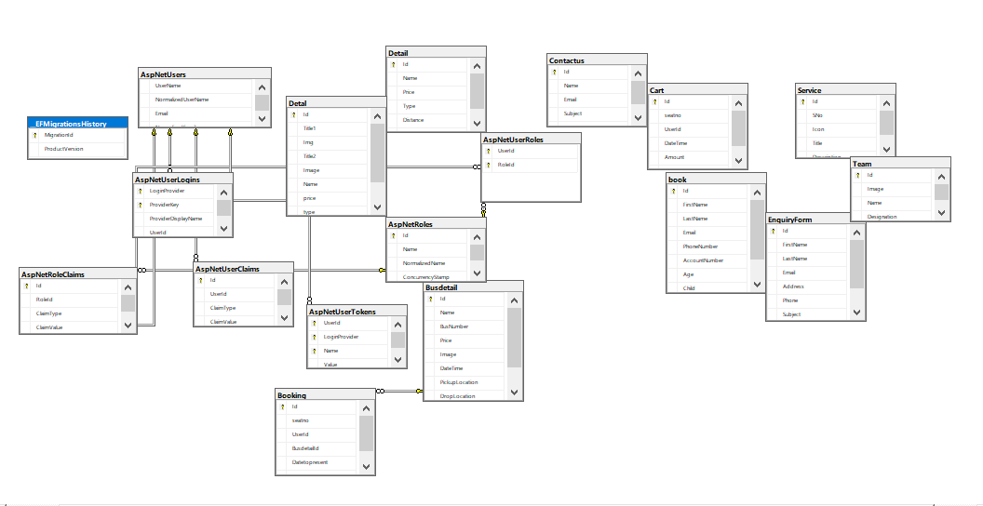

# Snapshot

User Panel landing page

~~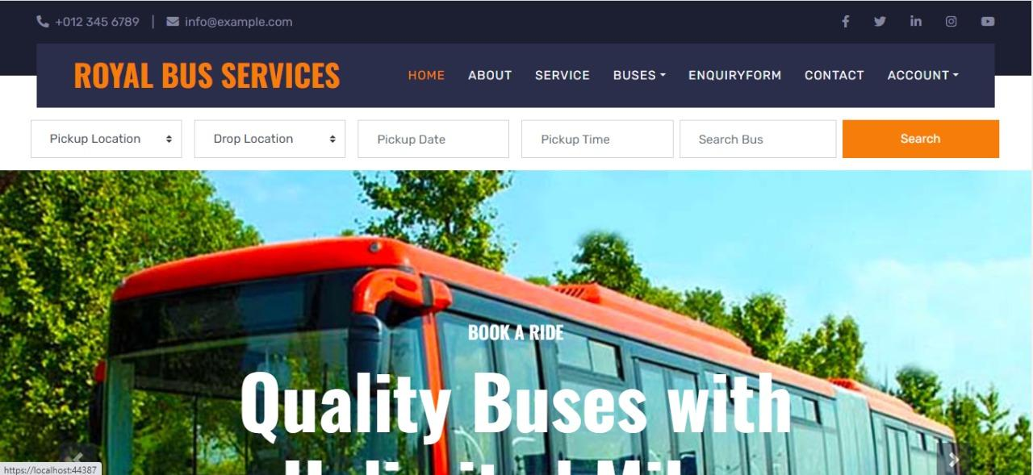~~

~~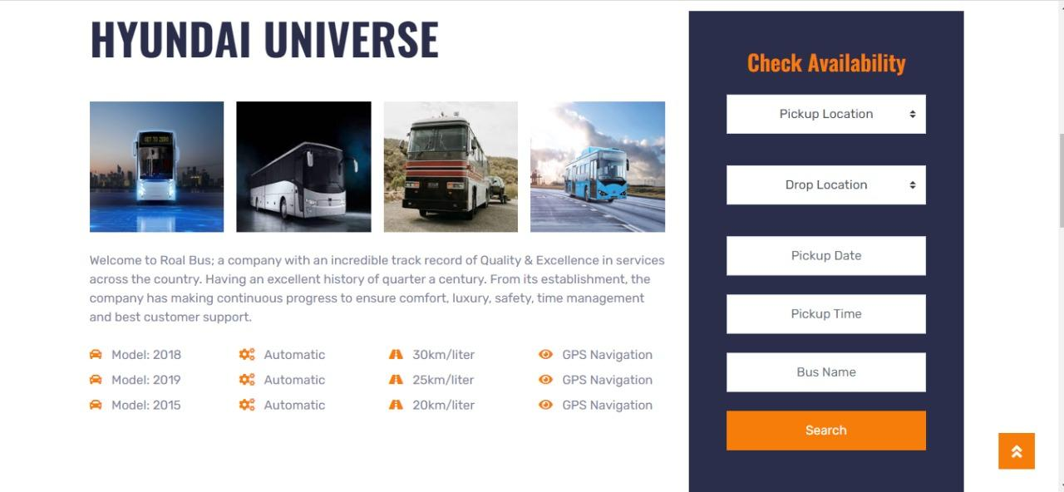~~

~~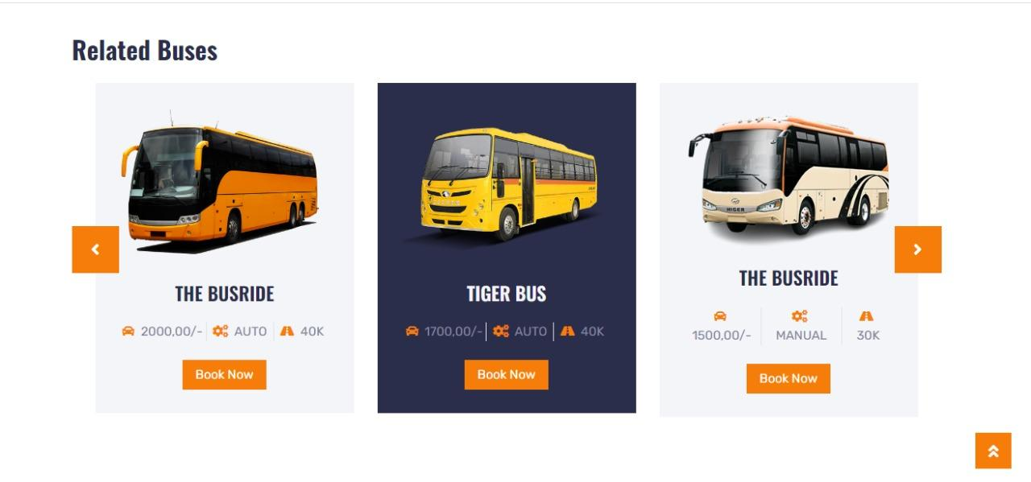~~

~~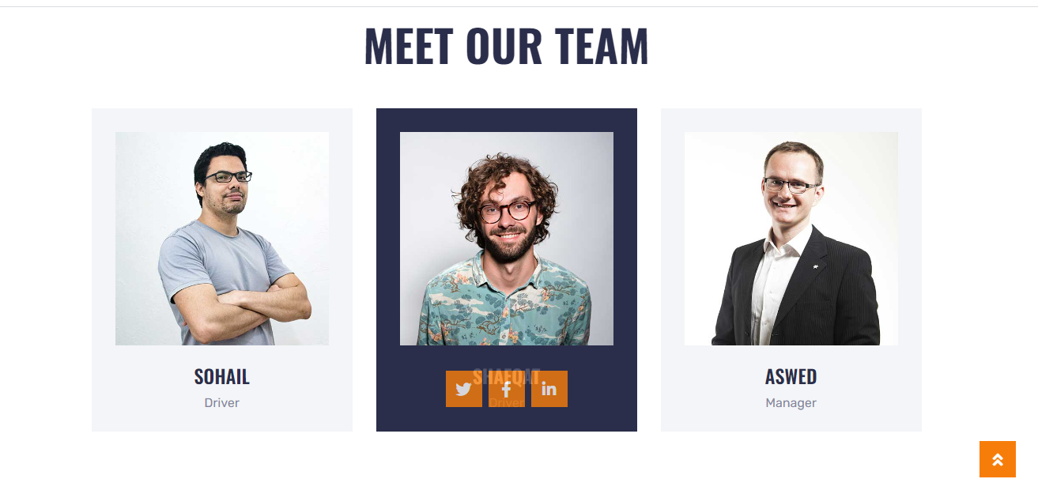~~

~~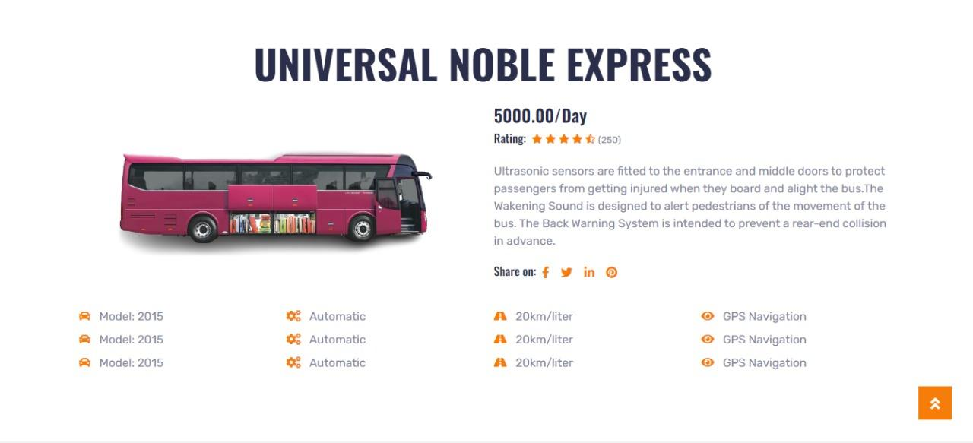~~

**Enquiry Form**

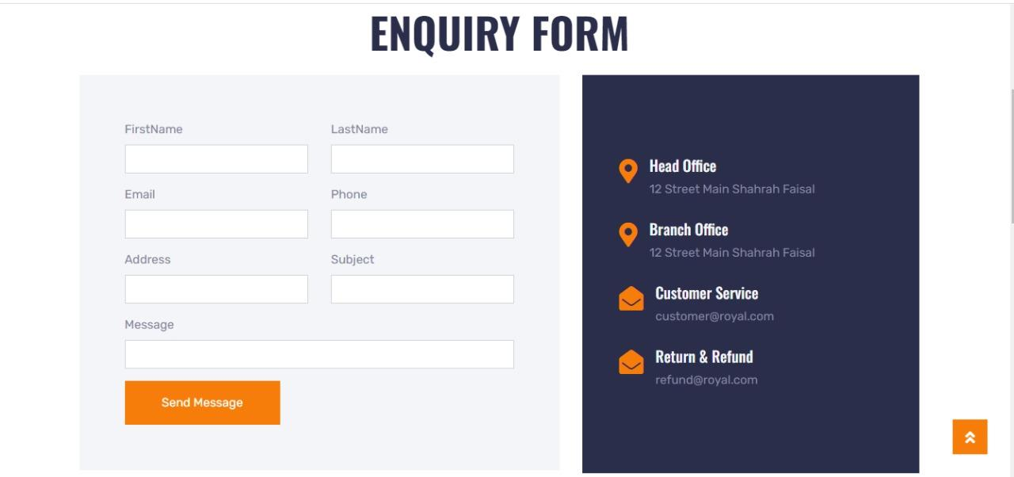

Booking Form

~~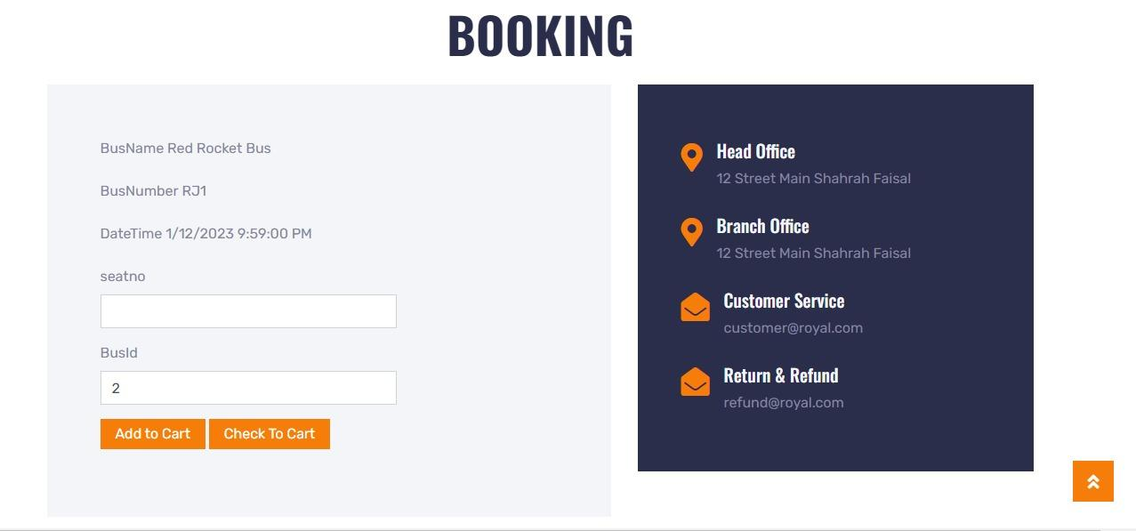~~

**Contact Us**

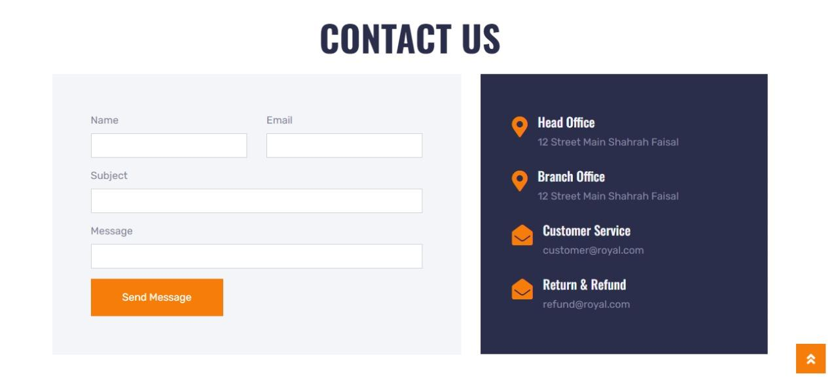

**Registration Form**

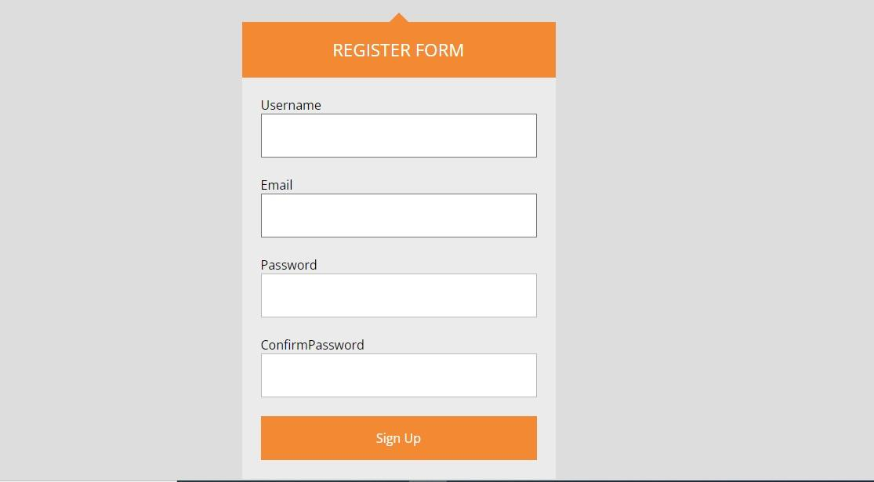

**Price List**

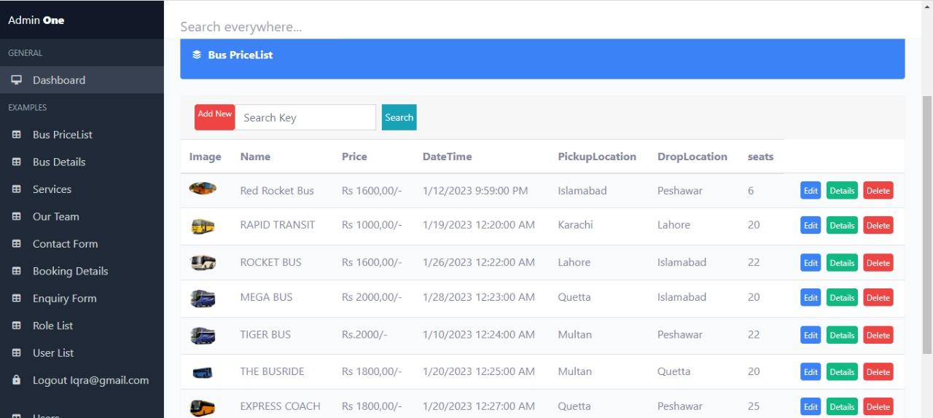

**Bus Avaibility**

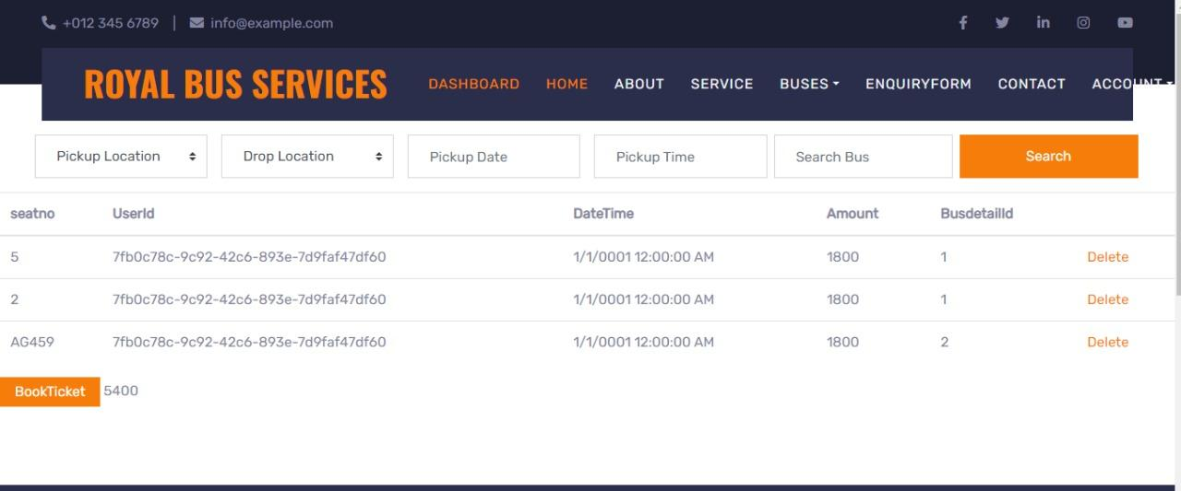

**Dashboard**

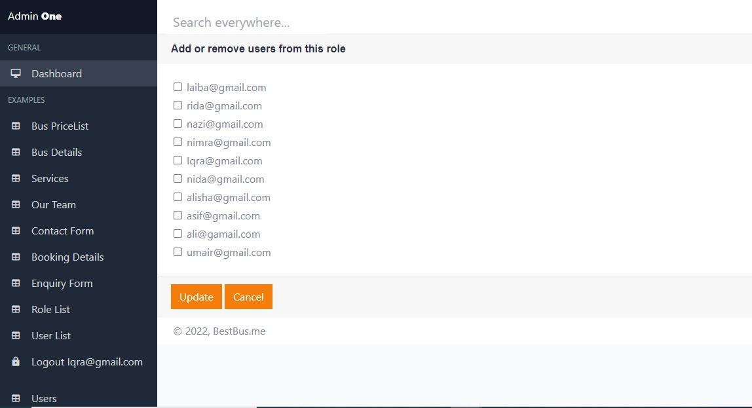

**Price List**



**Edit By Admin**

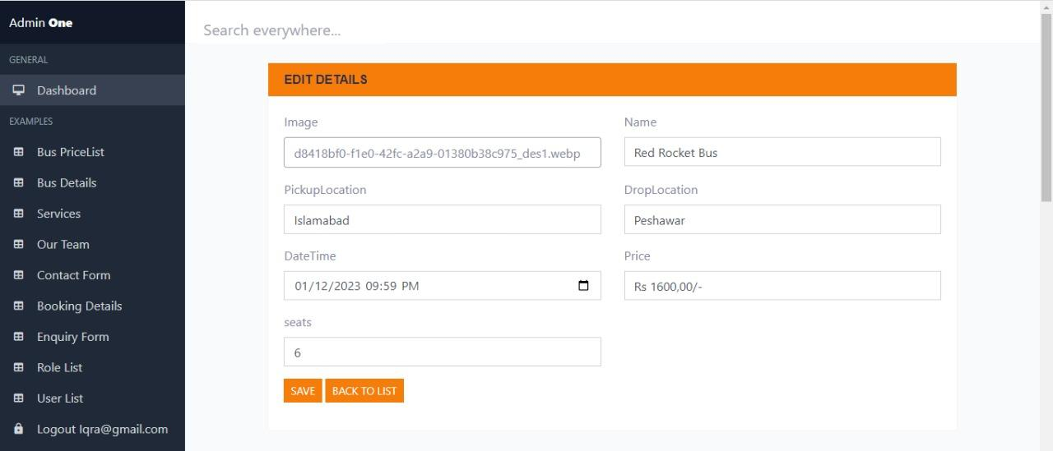

**Bus Detail**

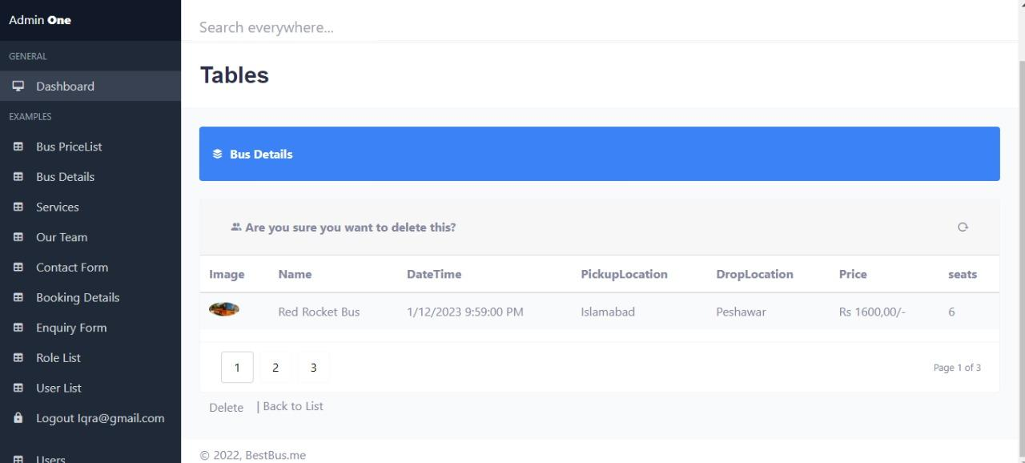



**Tables**

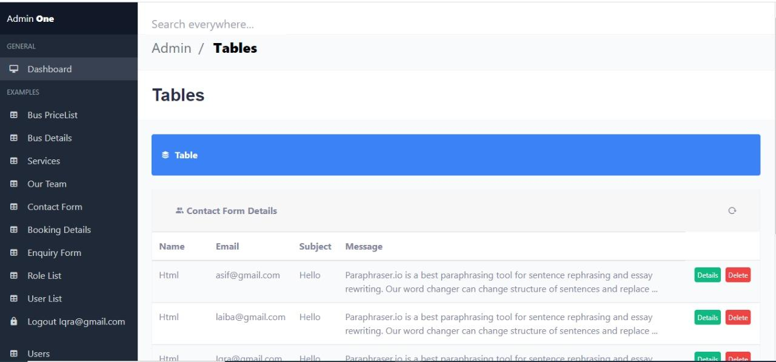

**Team Detail**

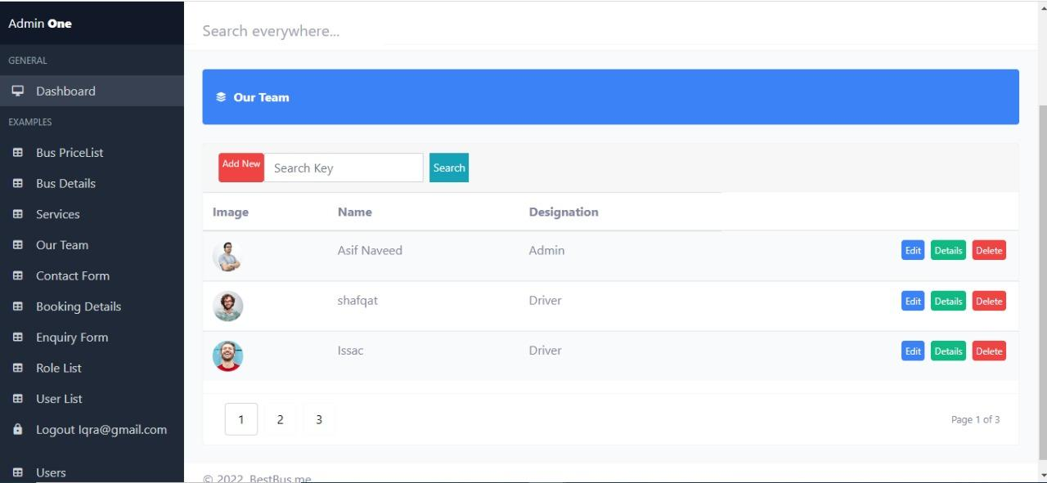

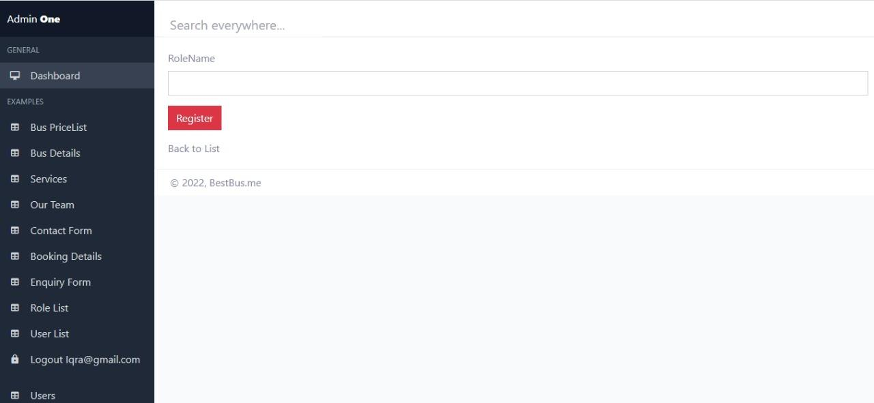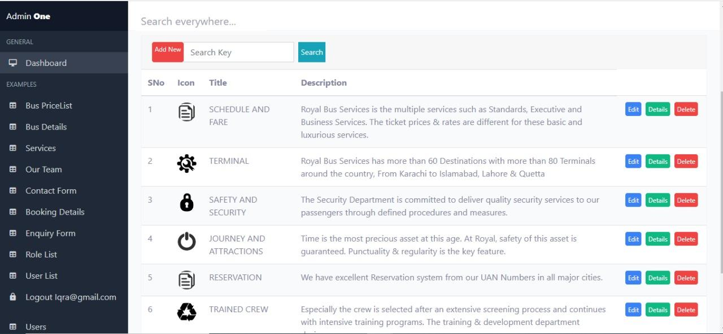

**Home Controller**

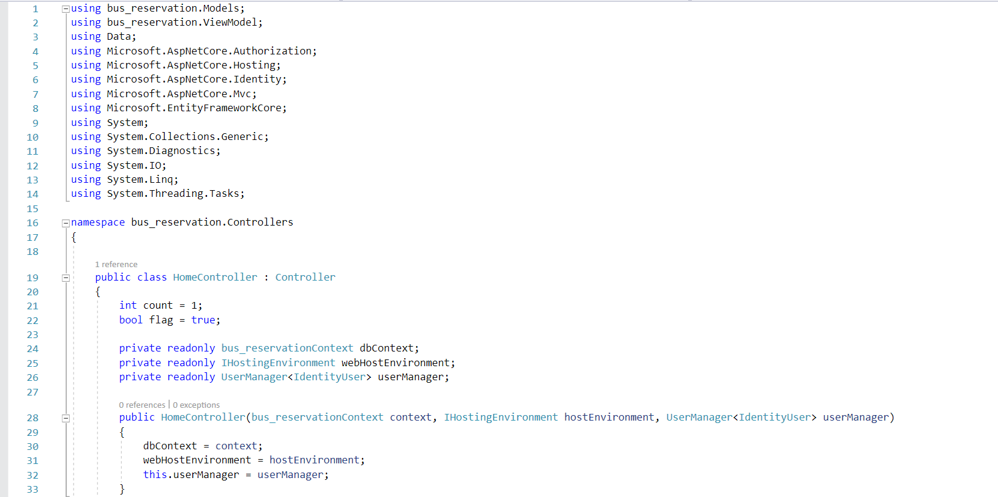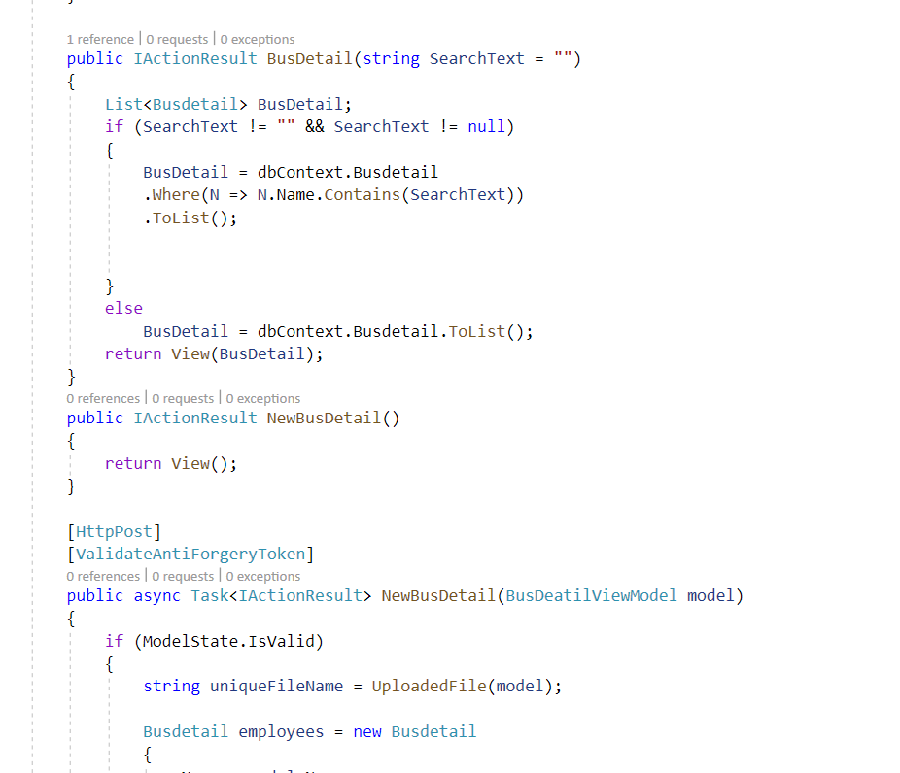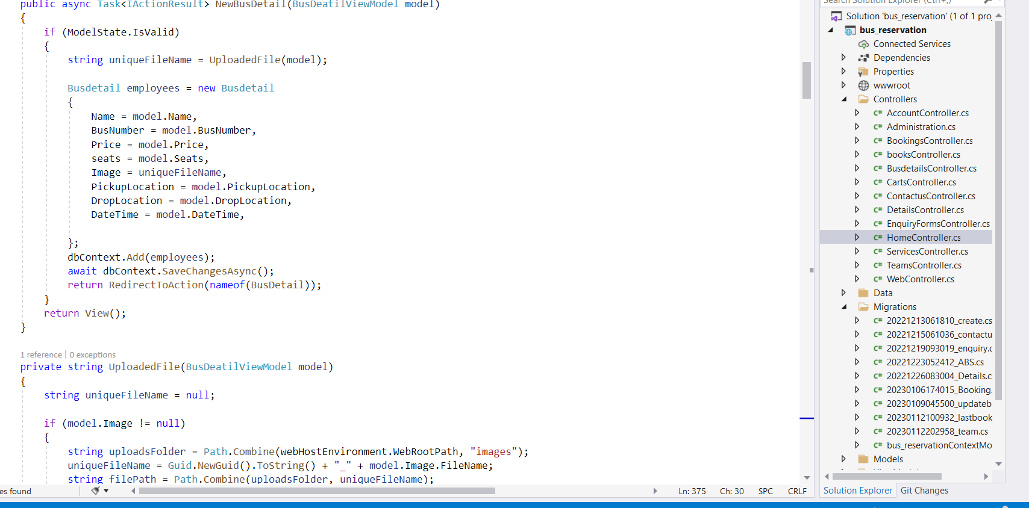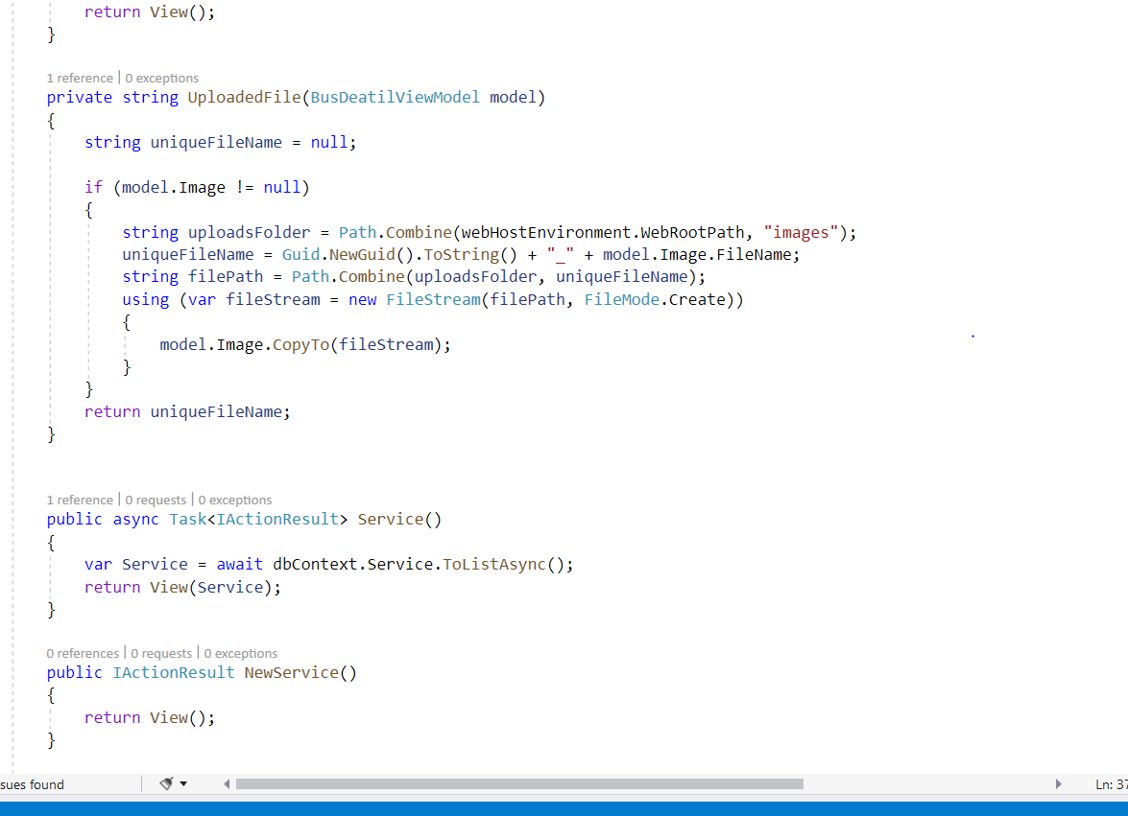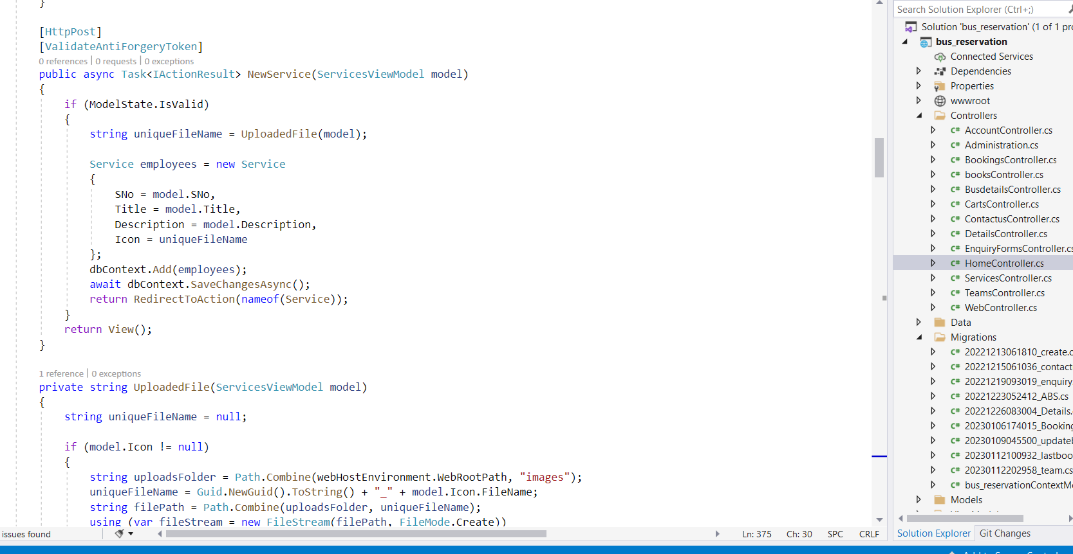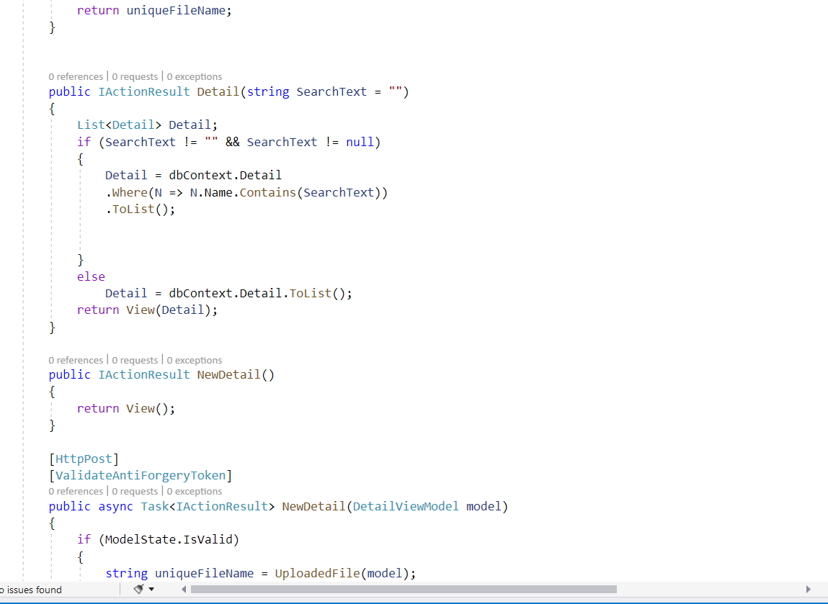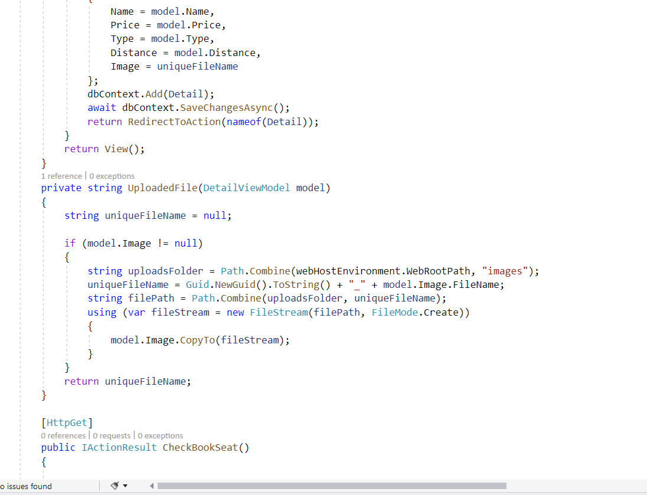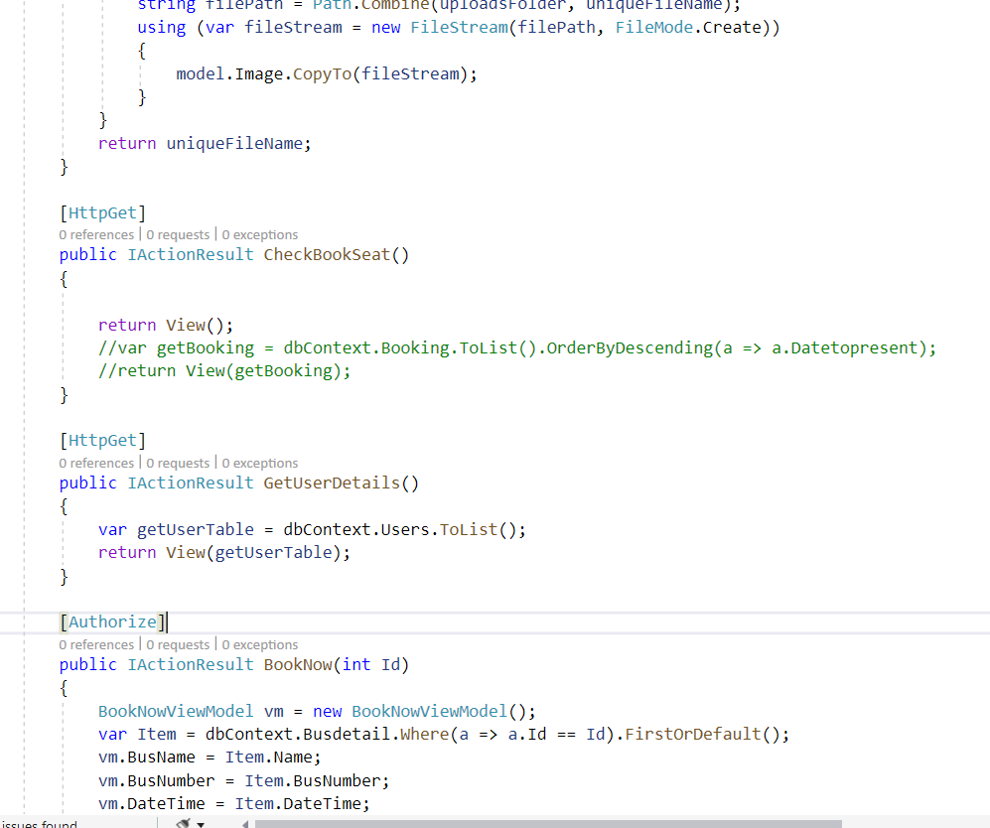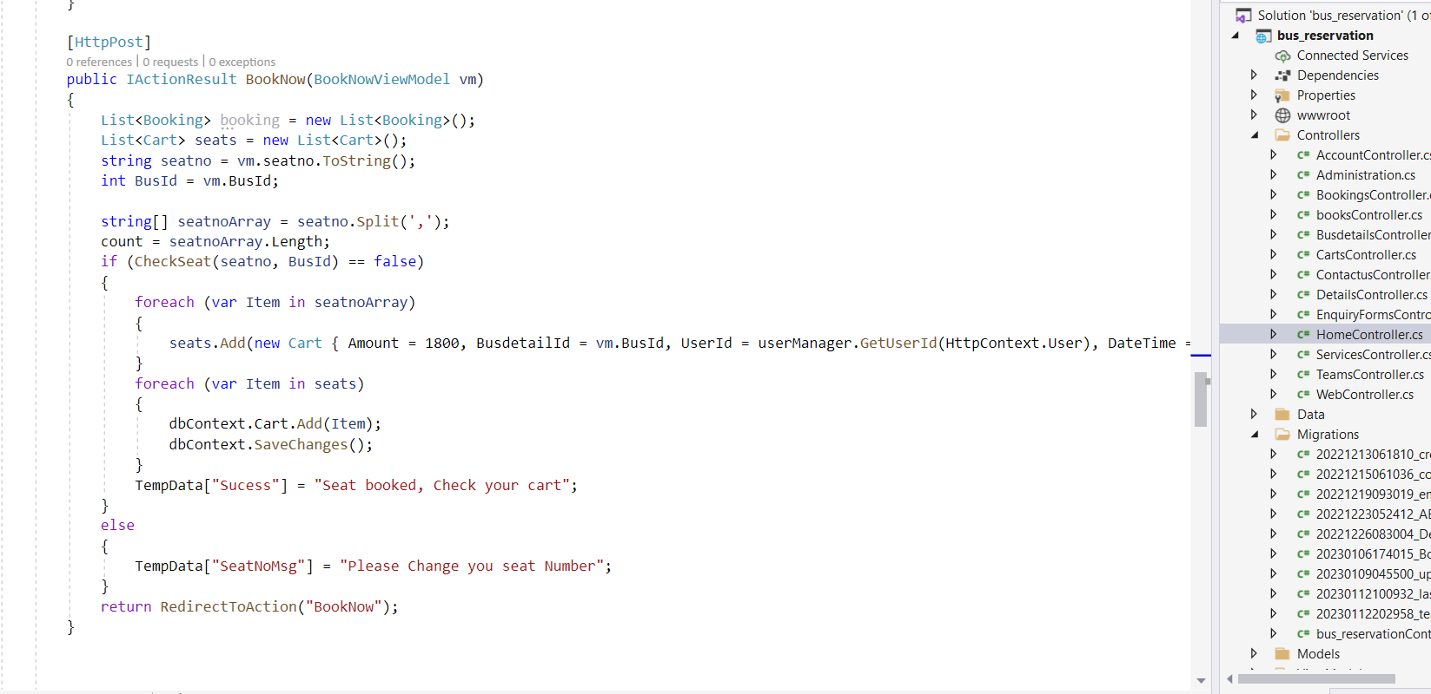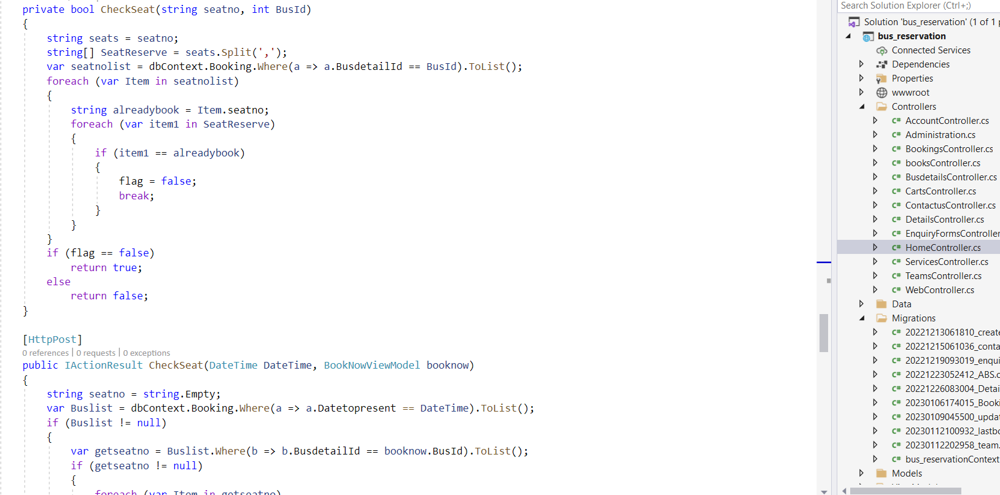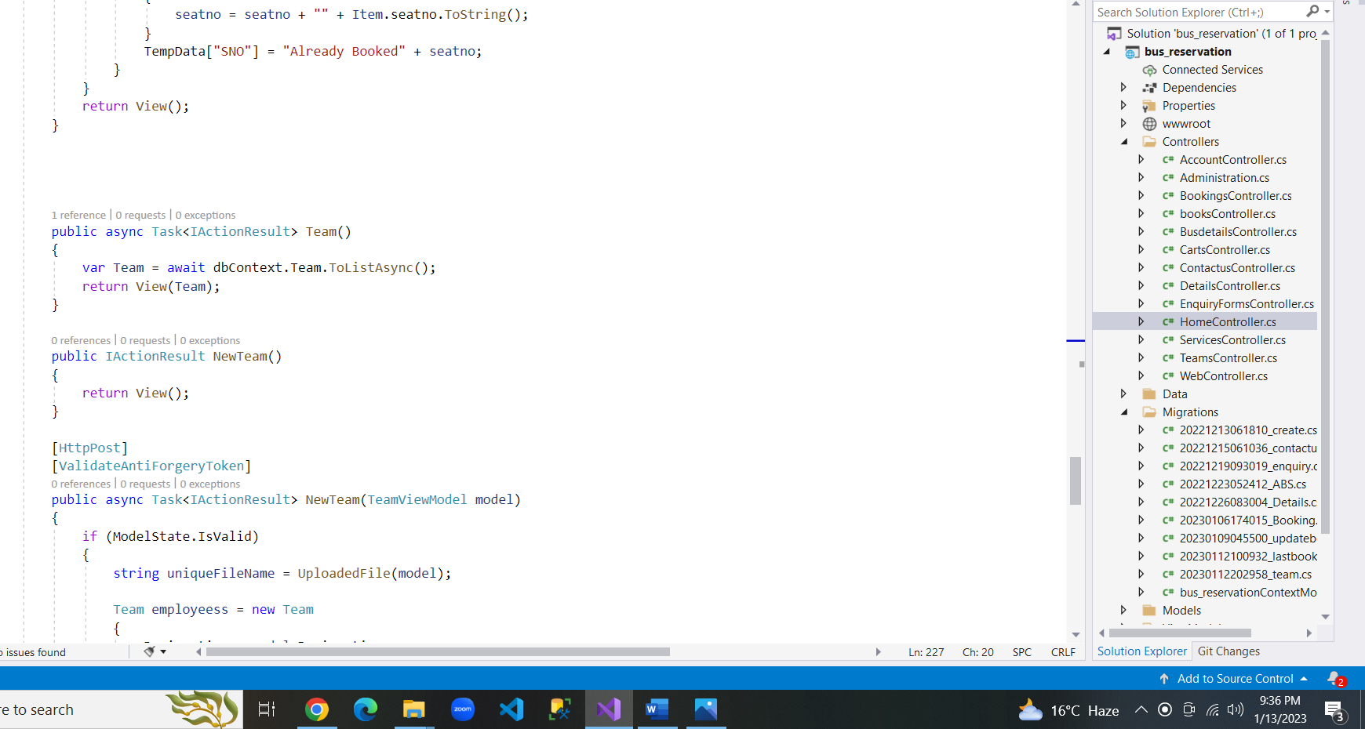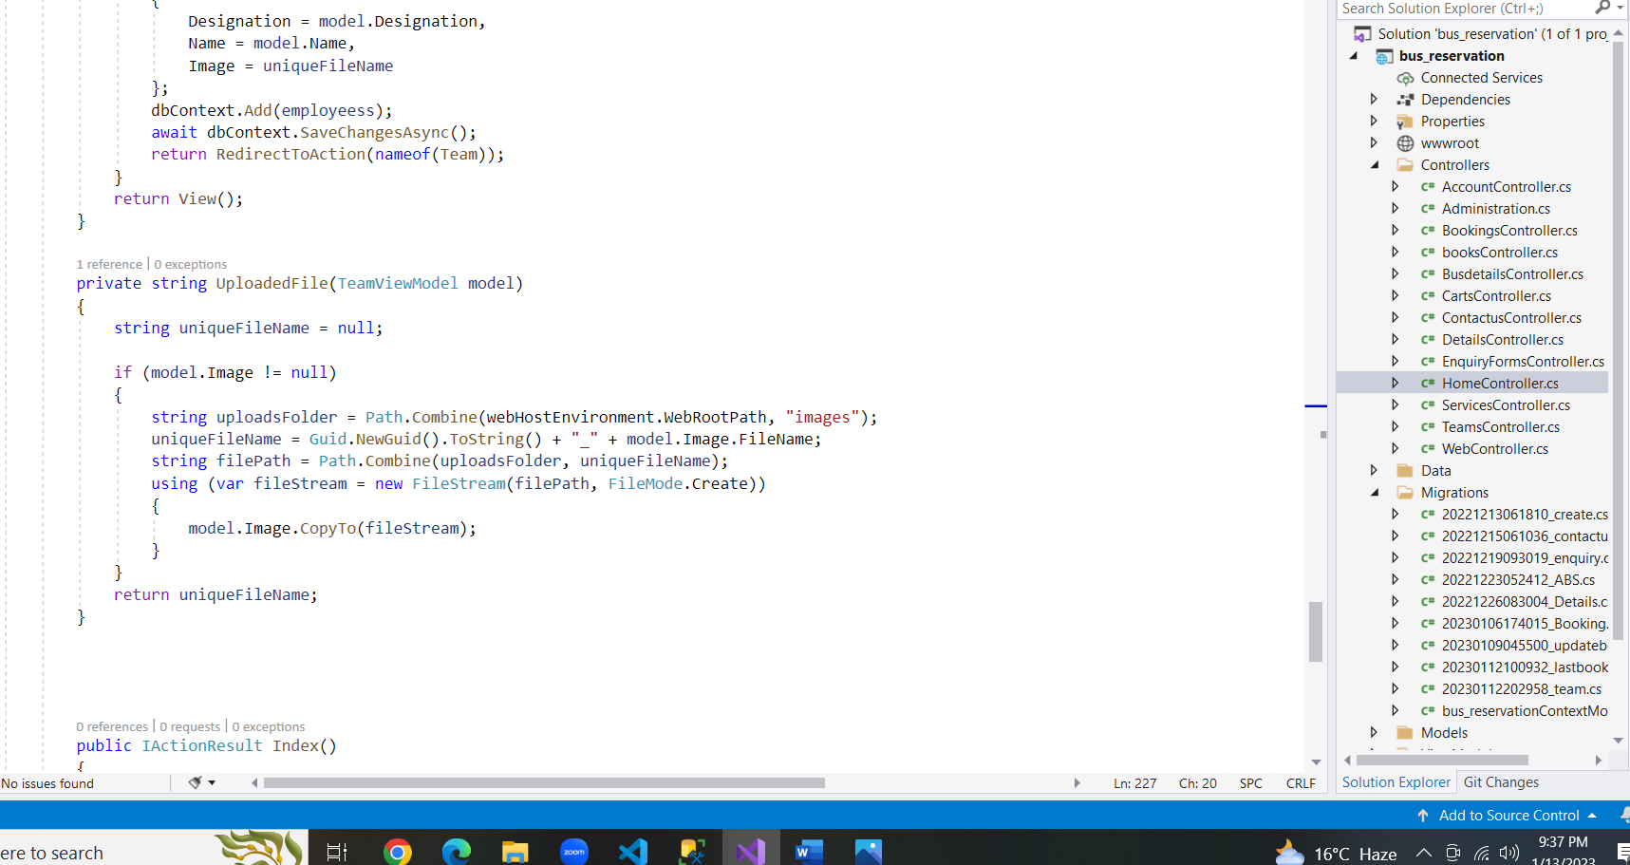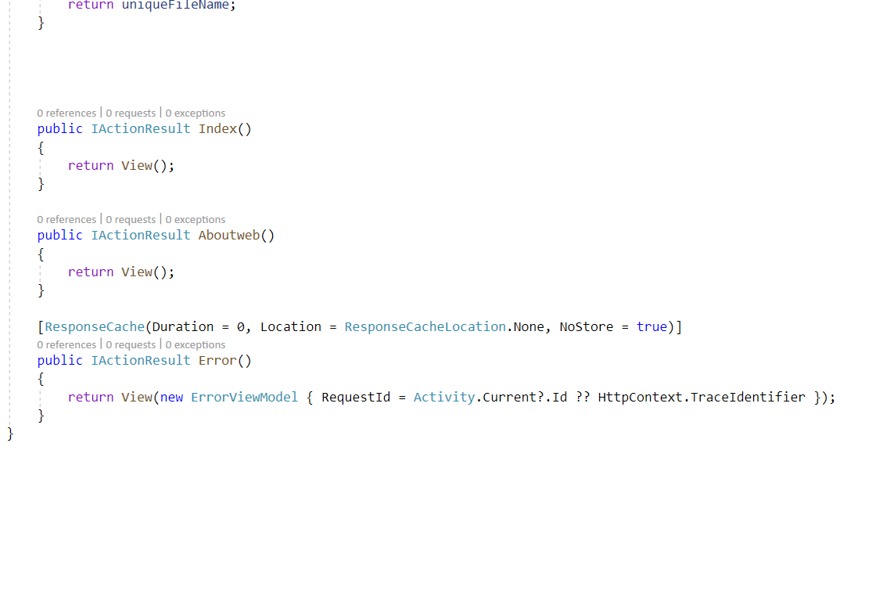

**Account Controller**

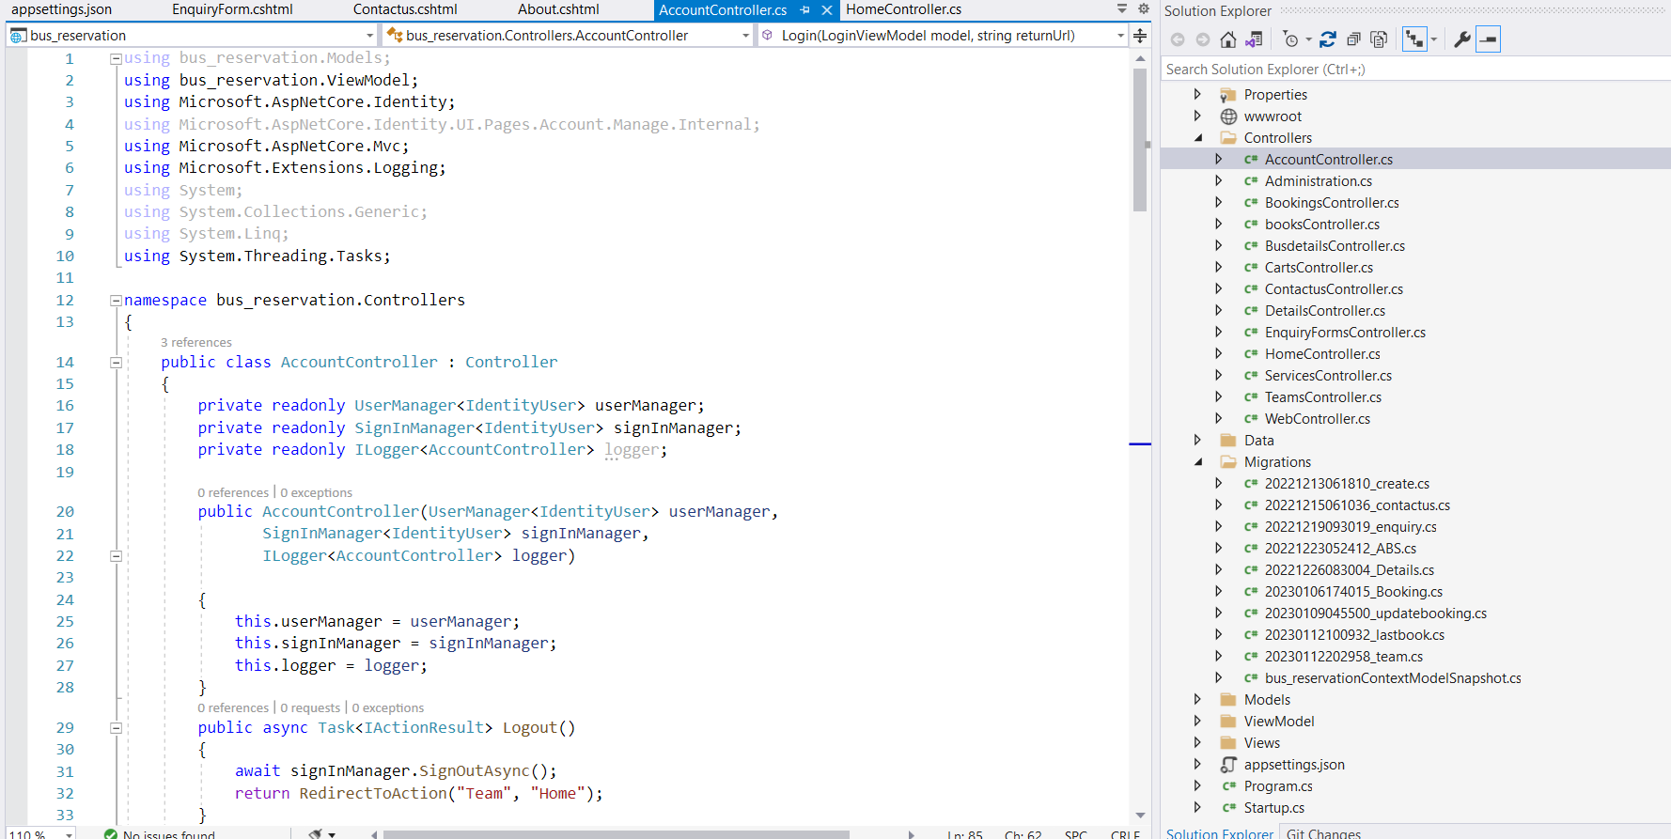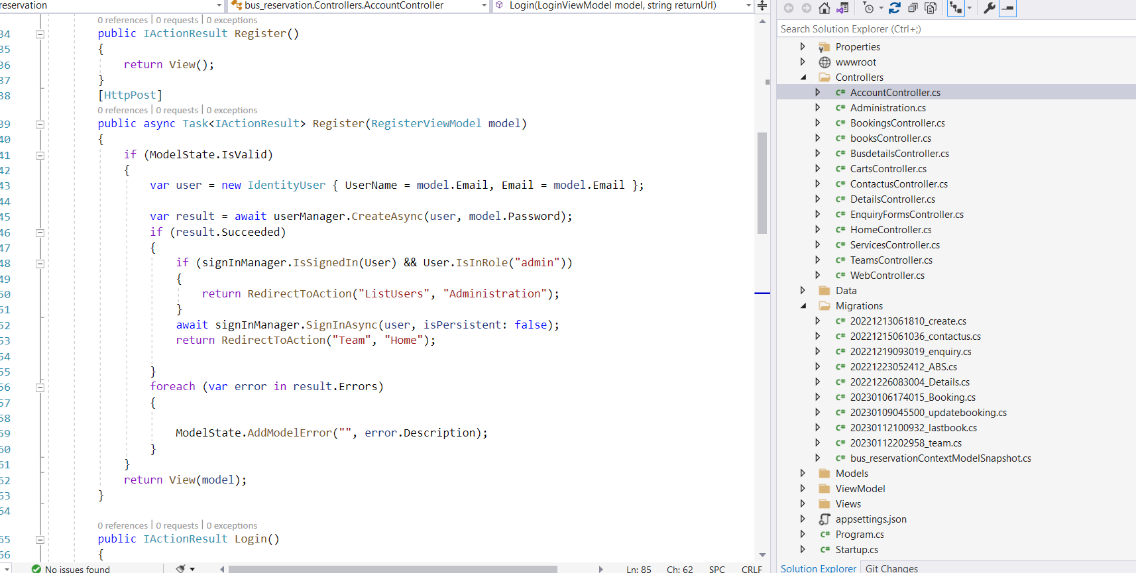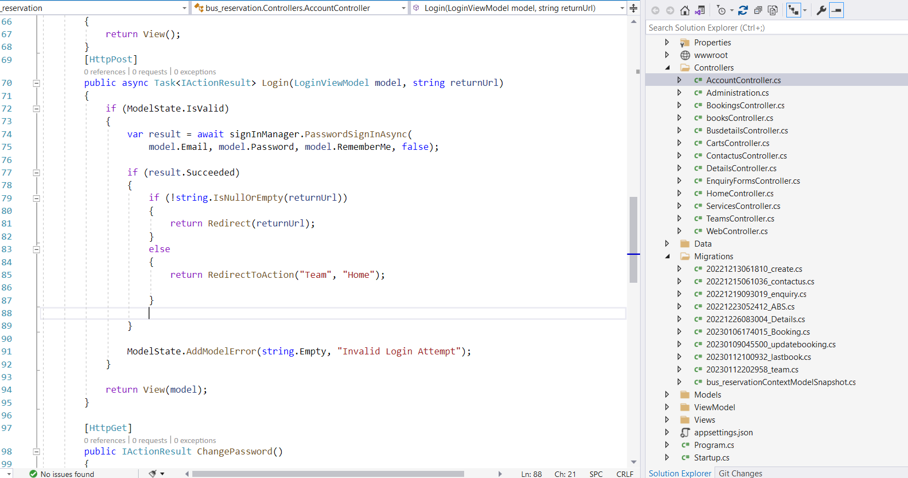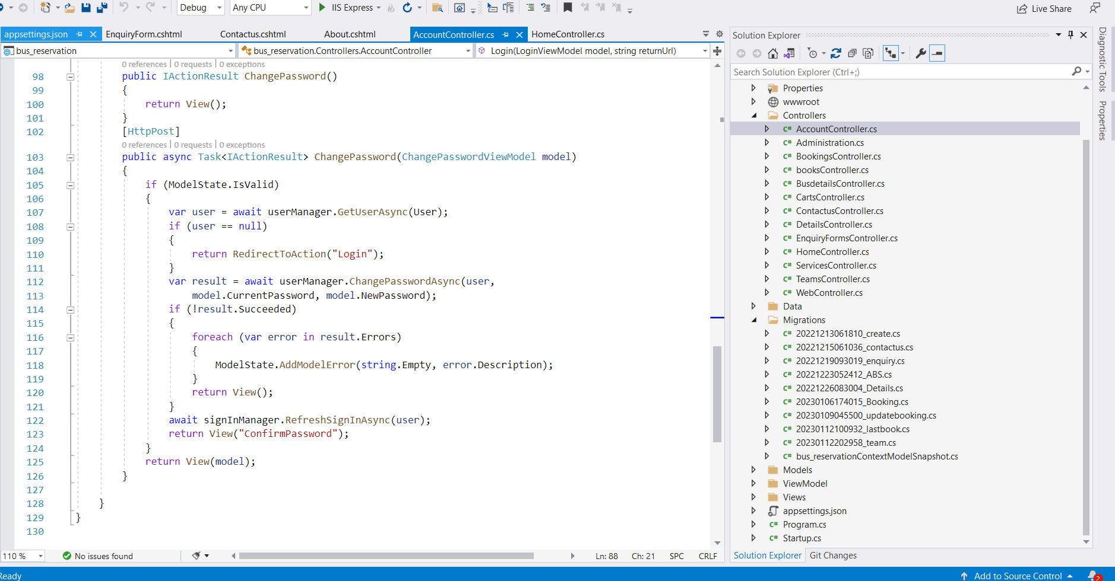

**Booking Controller**

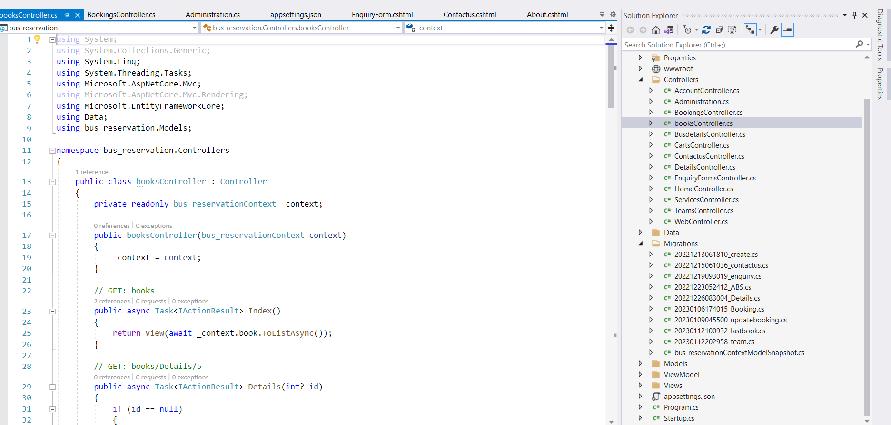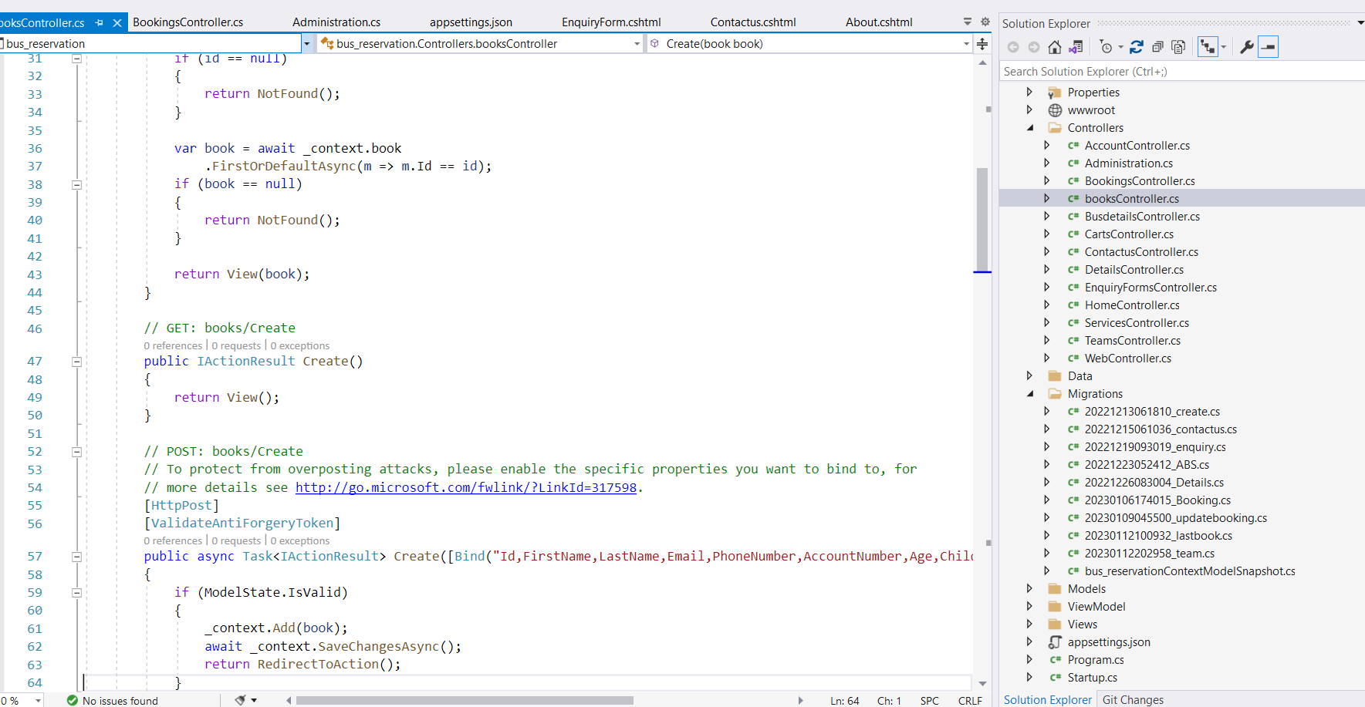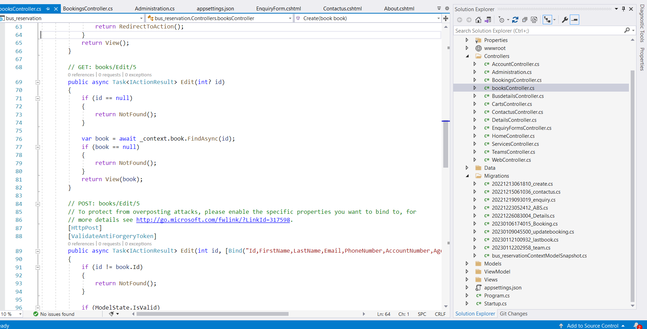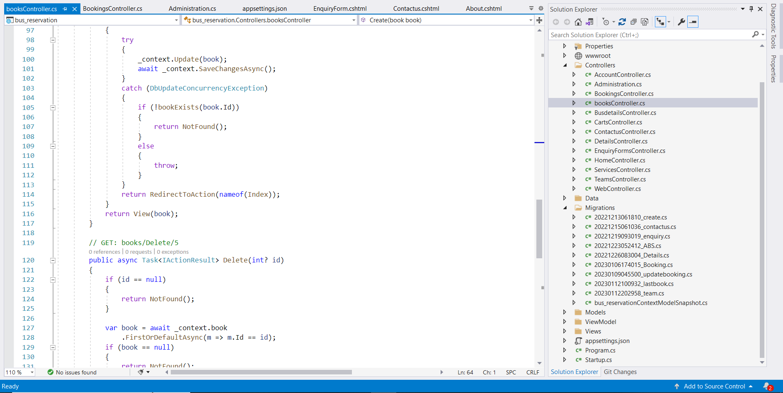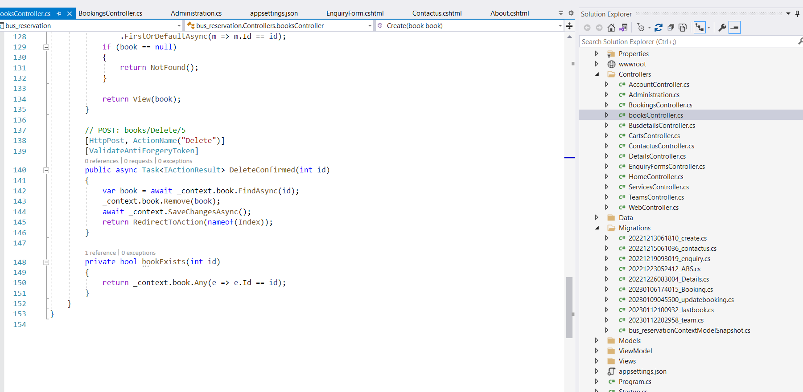

**Contact Controller**

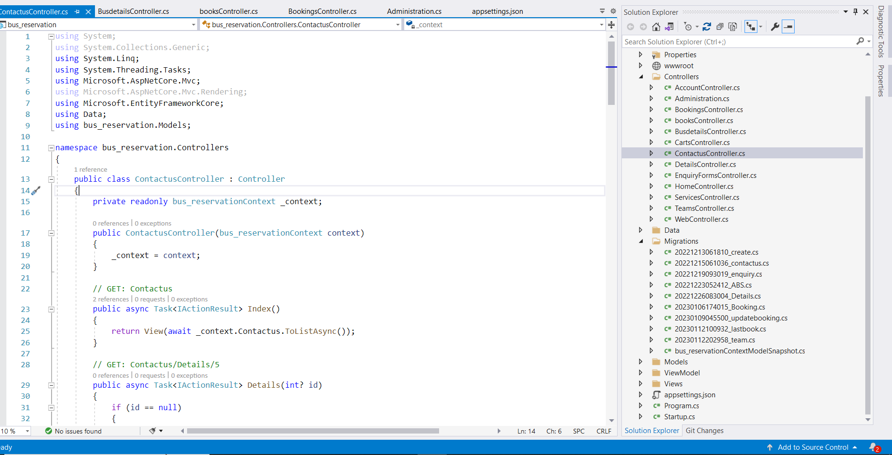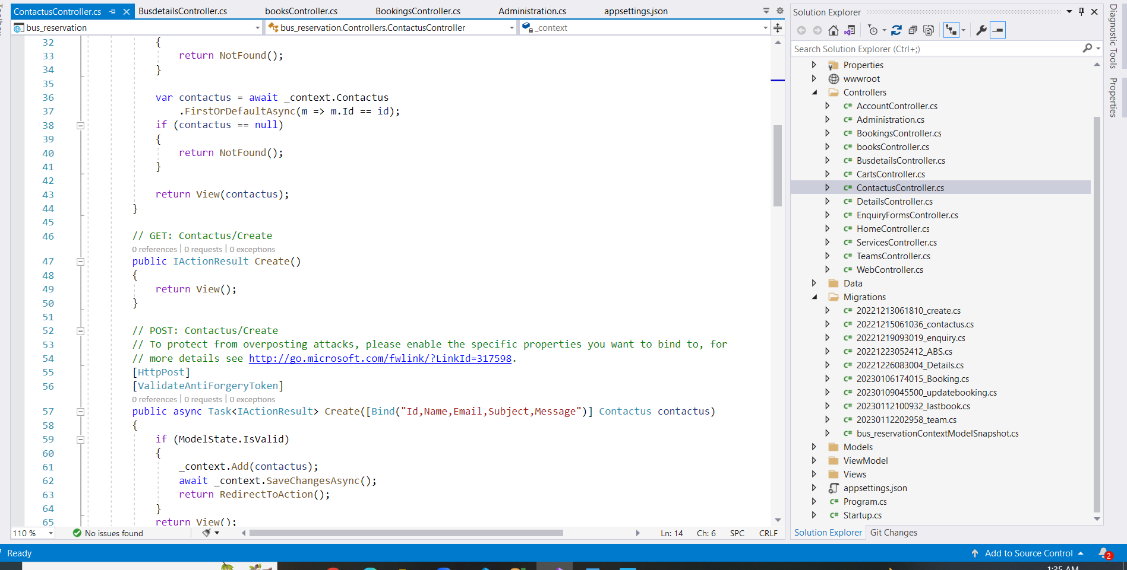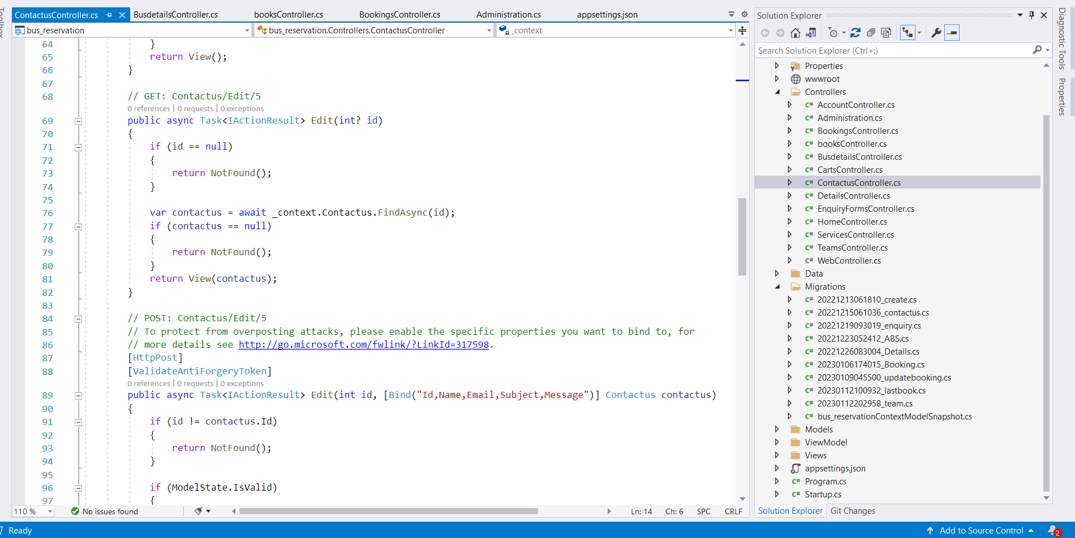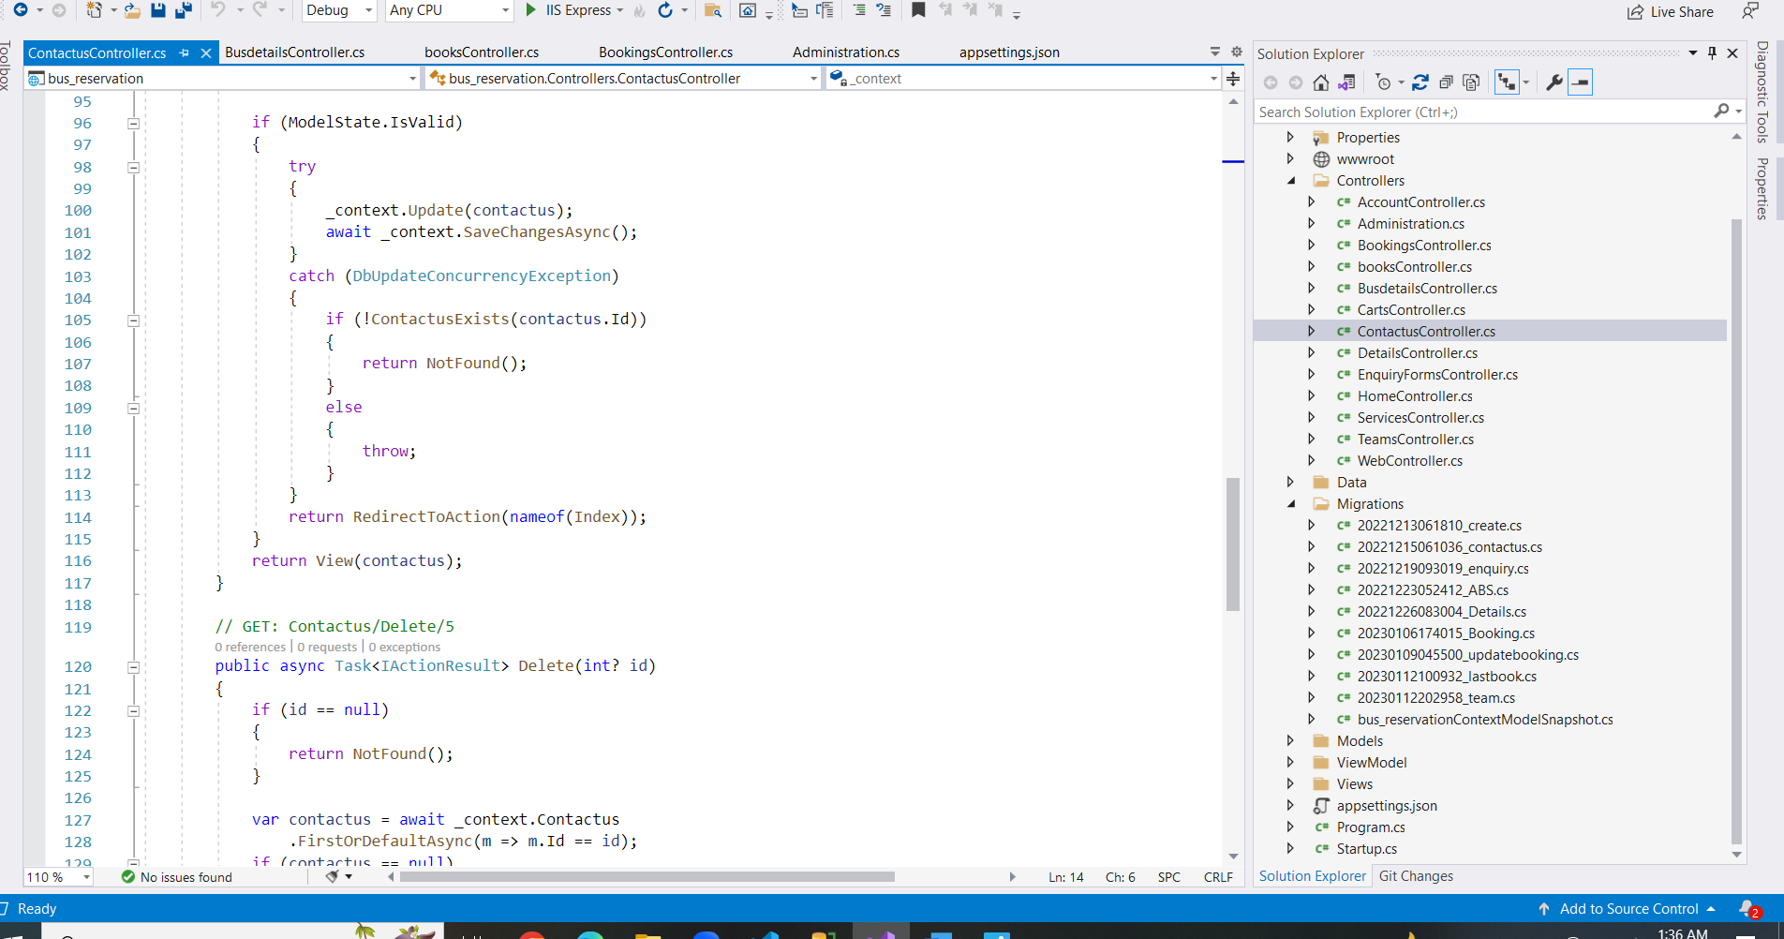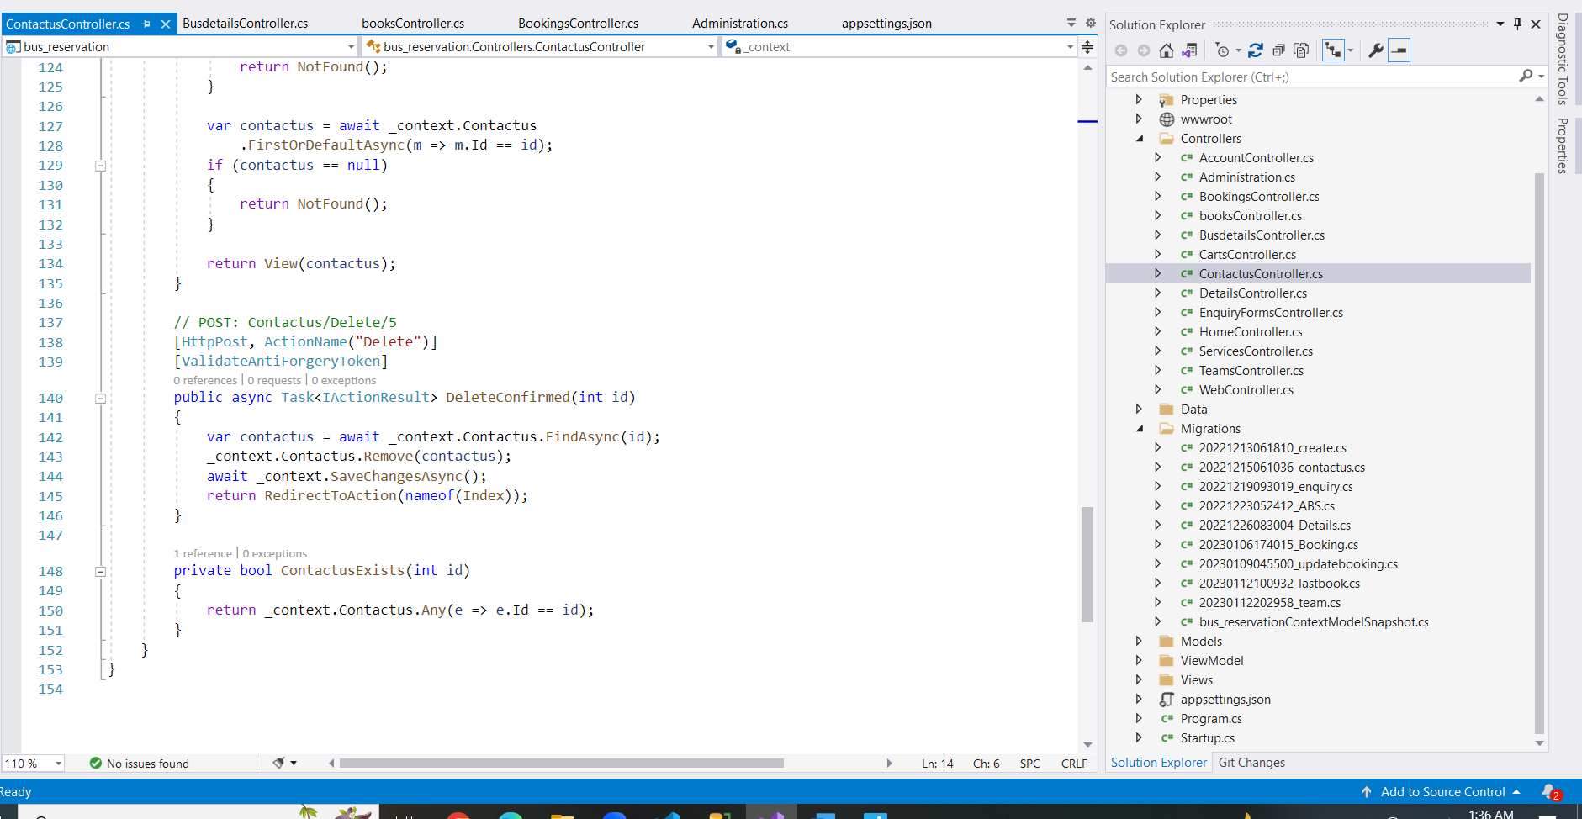

**Account View**

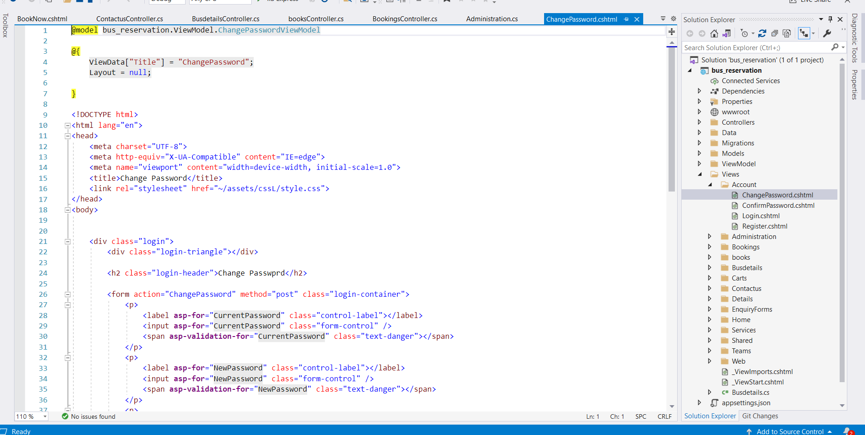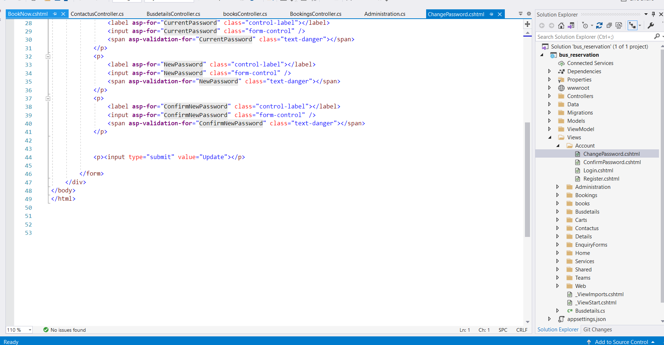

**Home View**

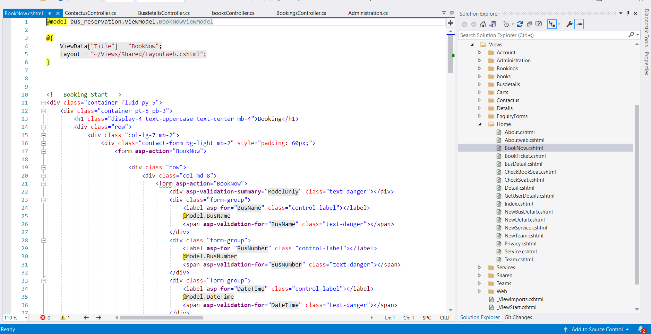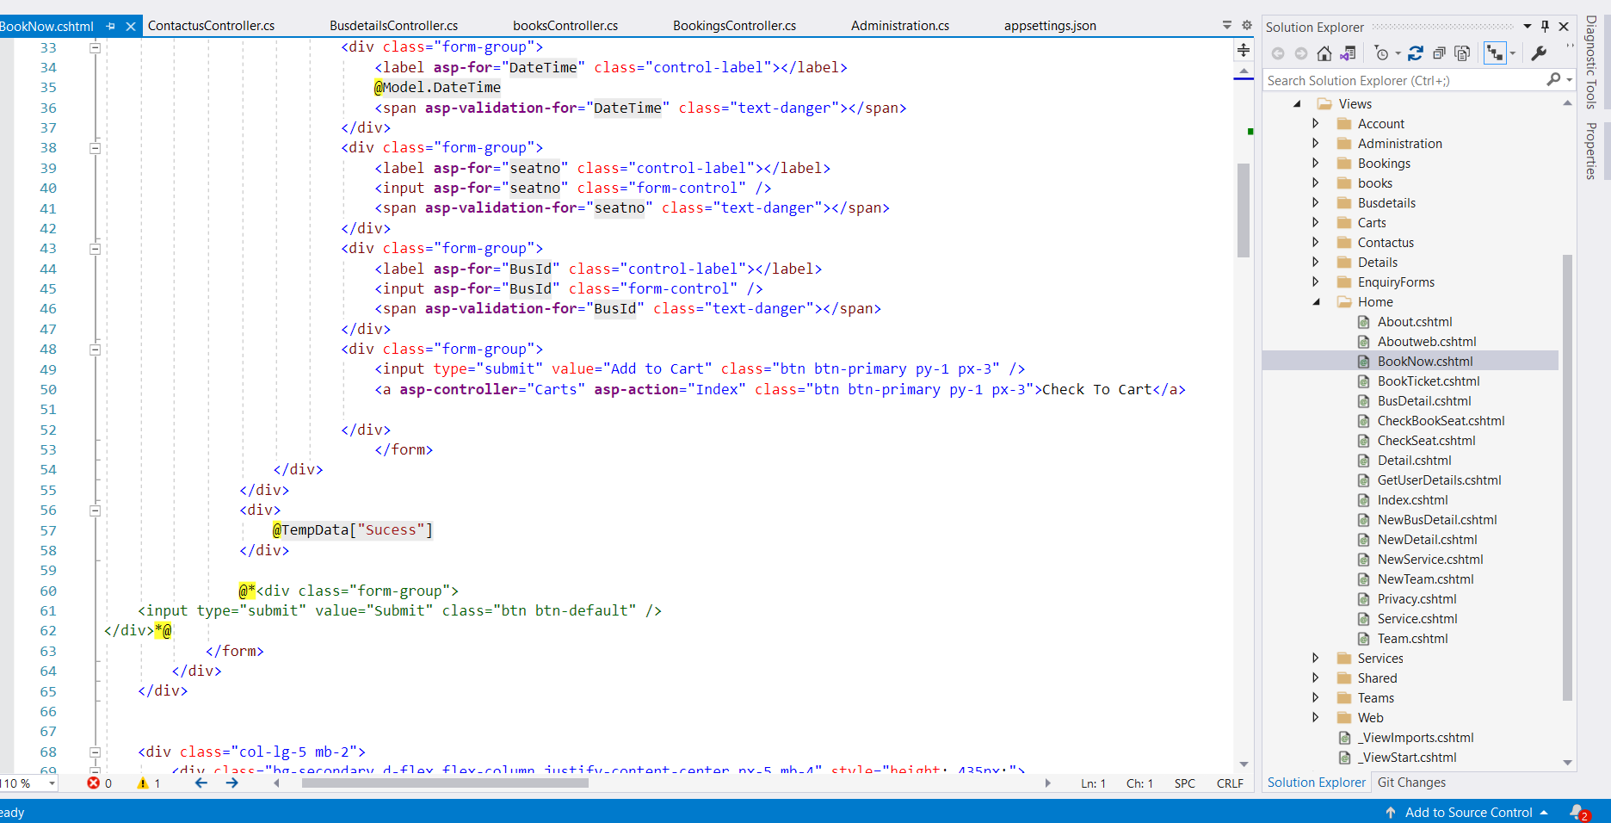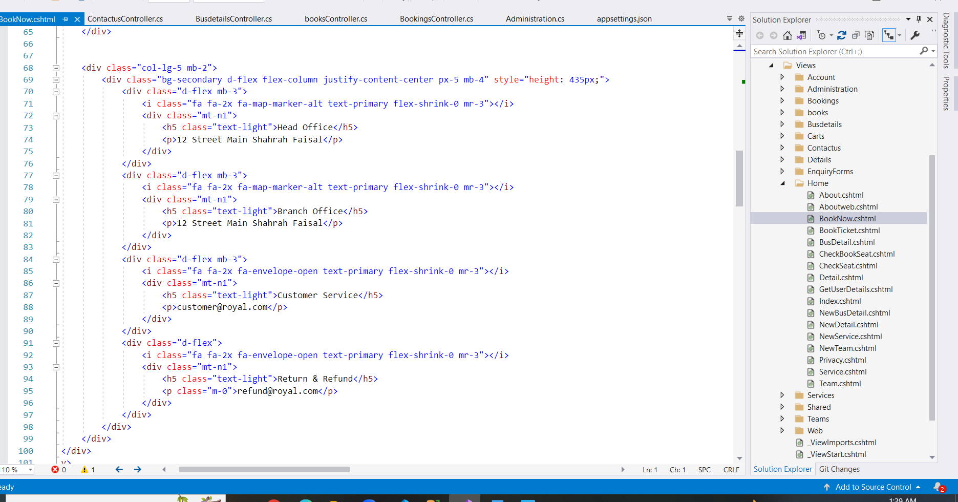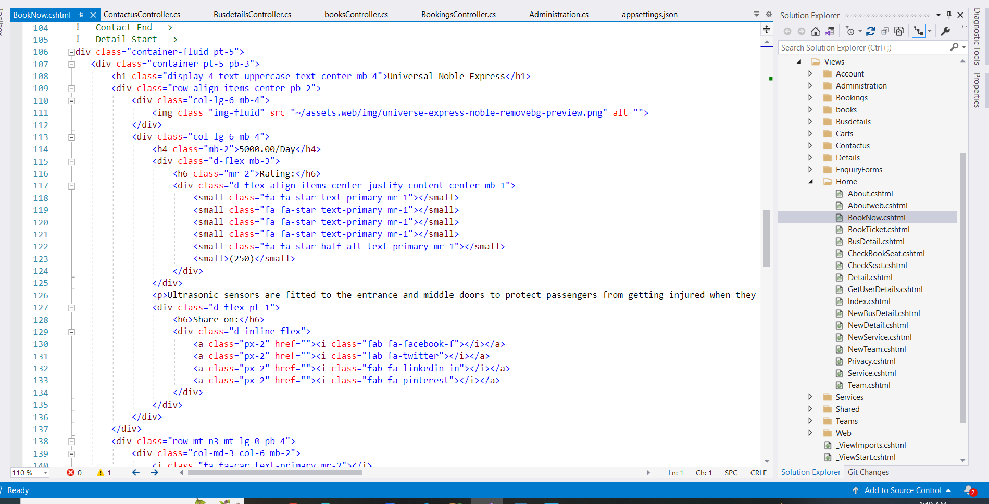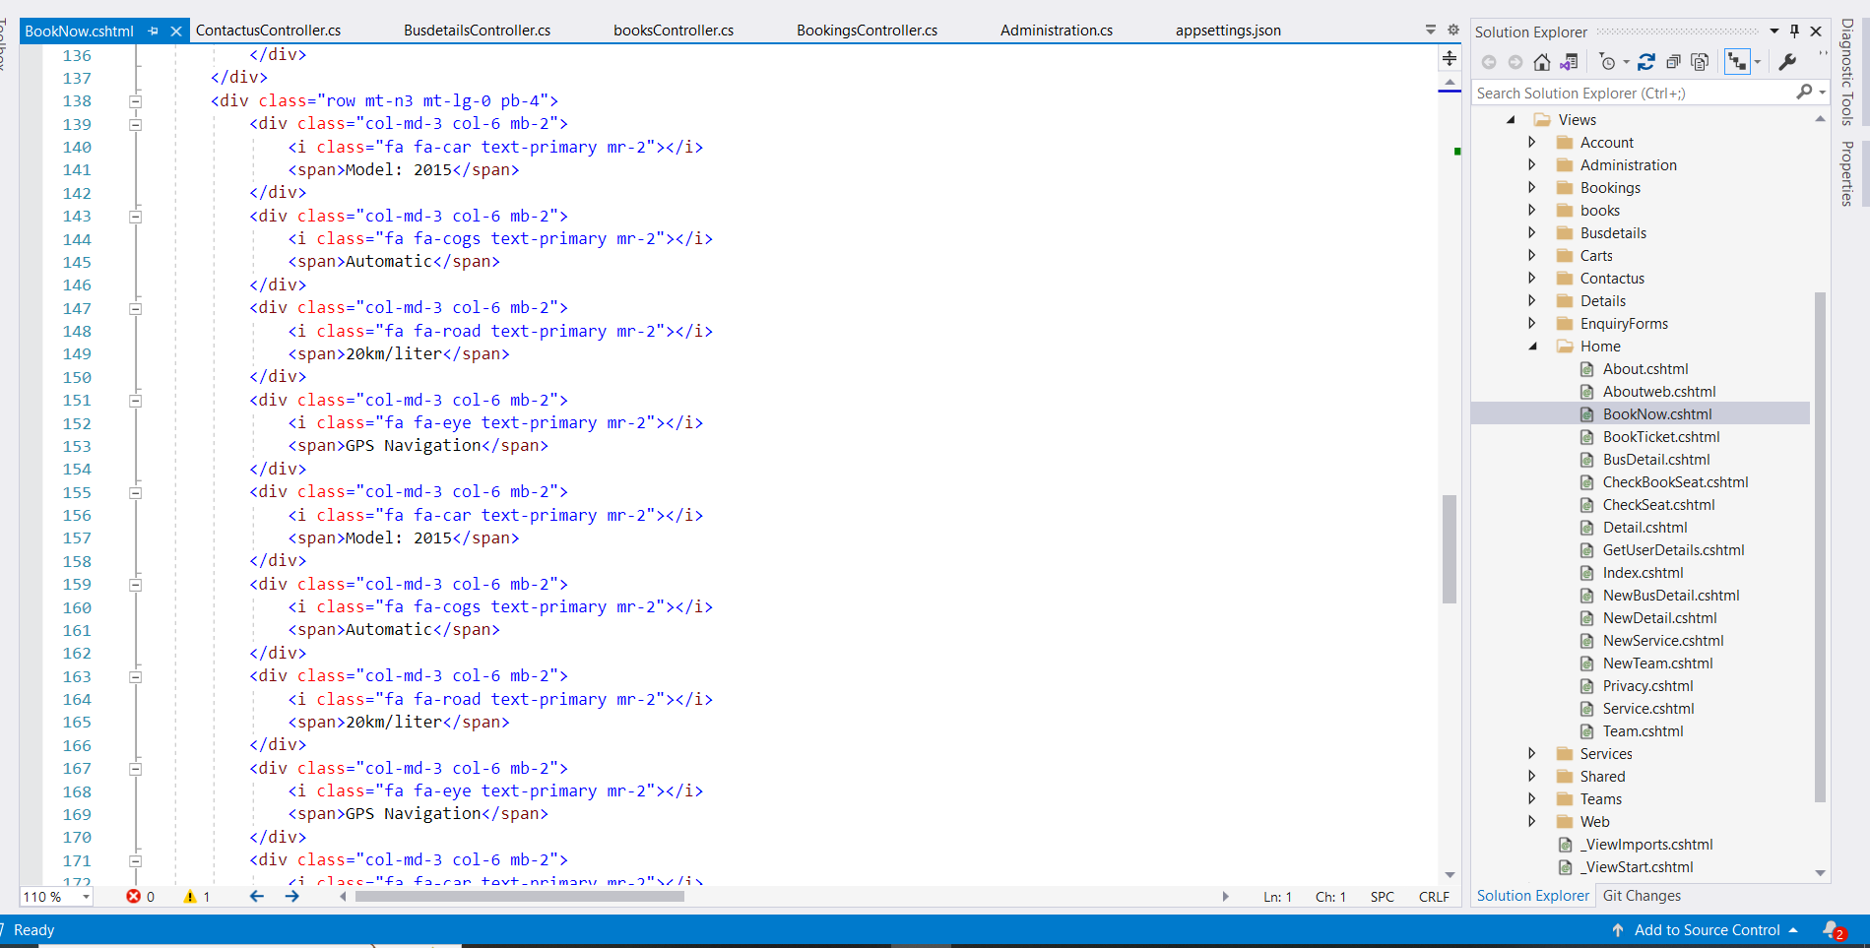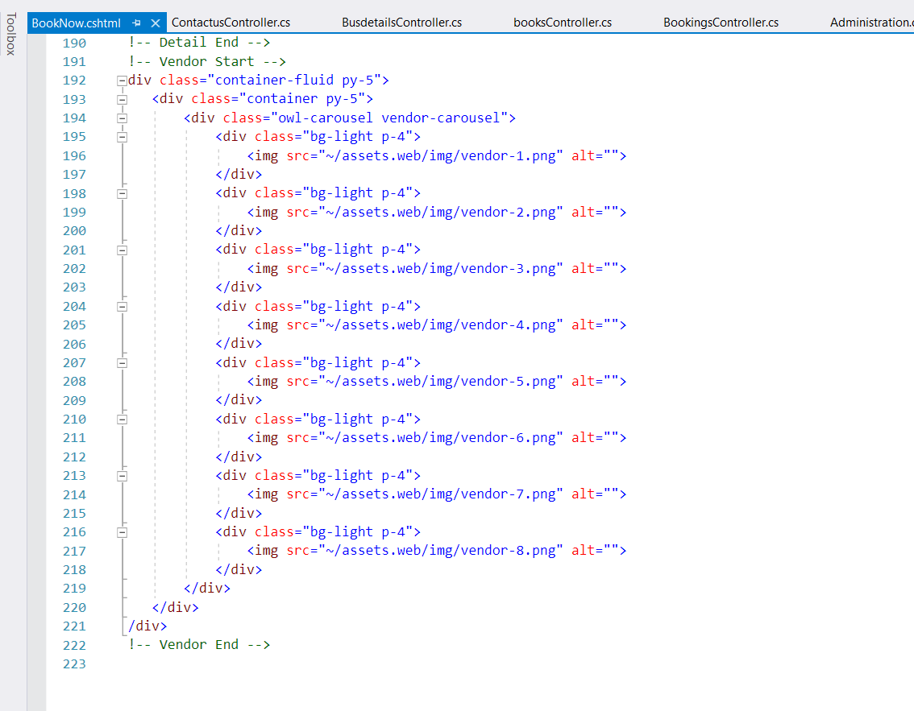

**Carts Model**

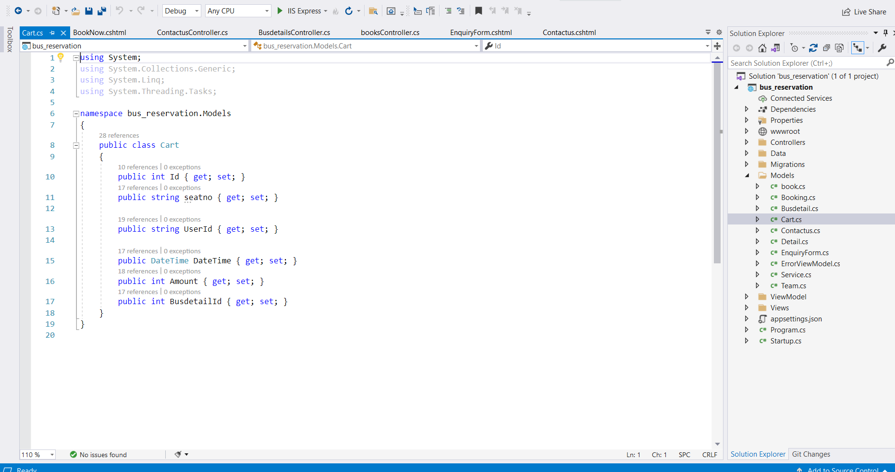

**Contact Model**

